Pull and send Sarasota County Permit Report for BSA -Pull this on every month on the 14th
3. Permit Table
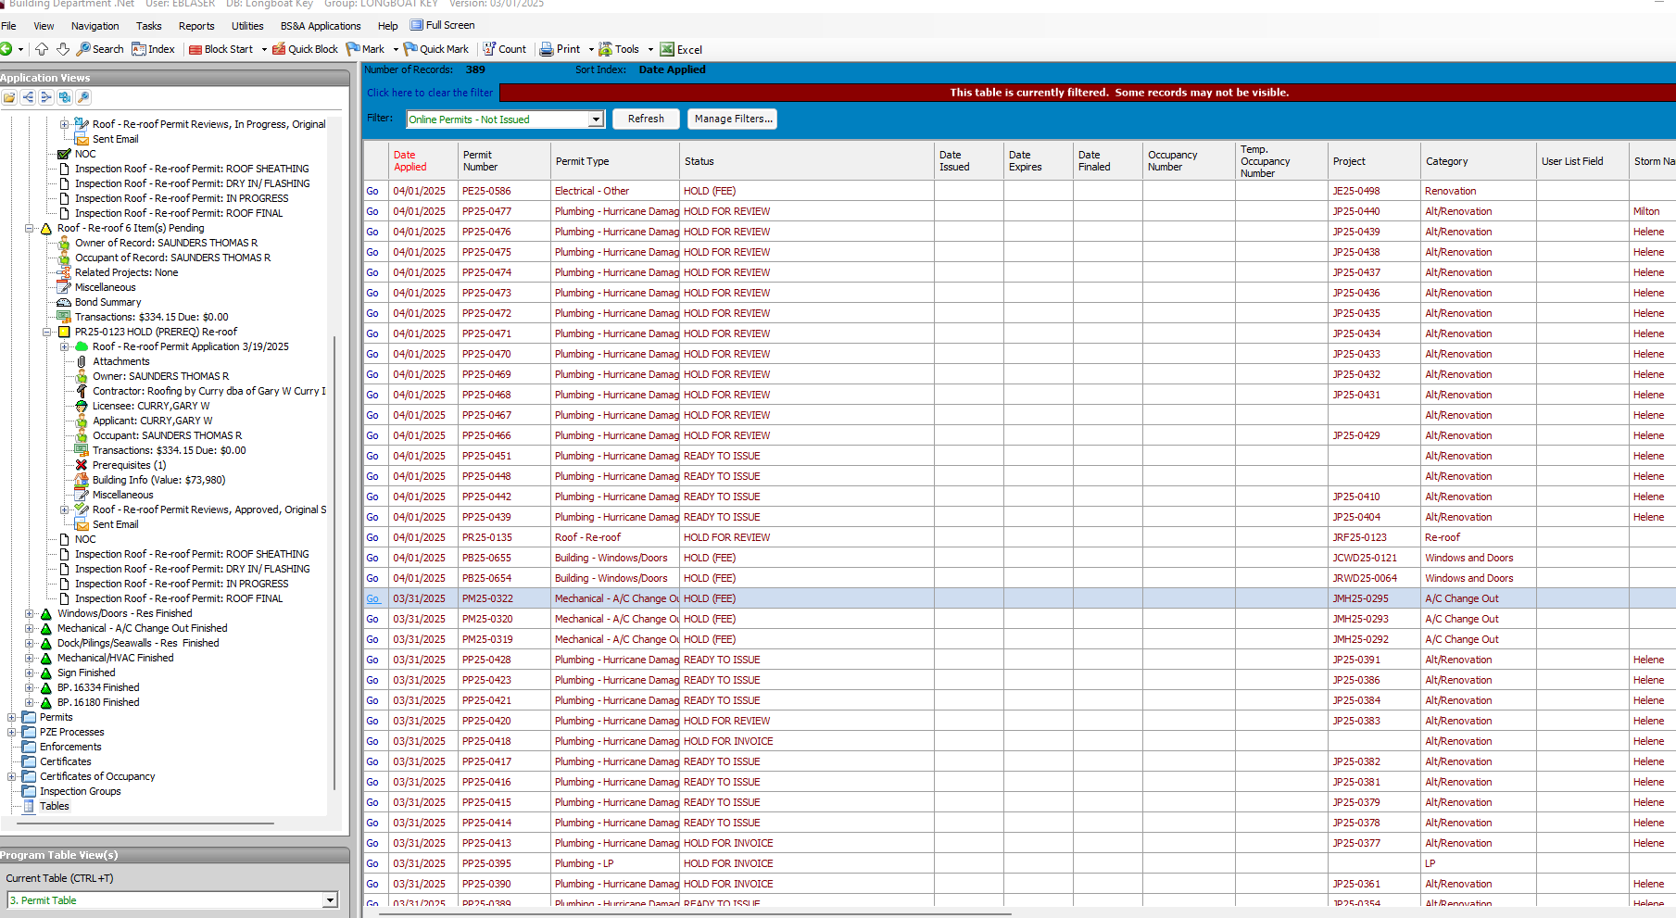
Filter-Sarasota Appraiser Filter
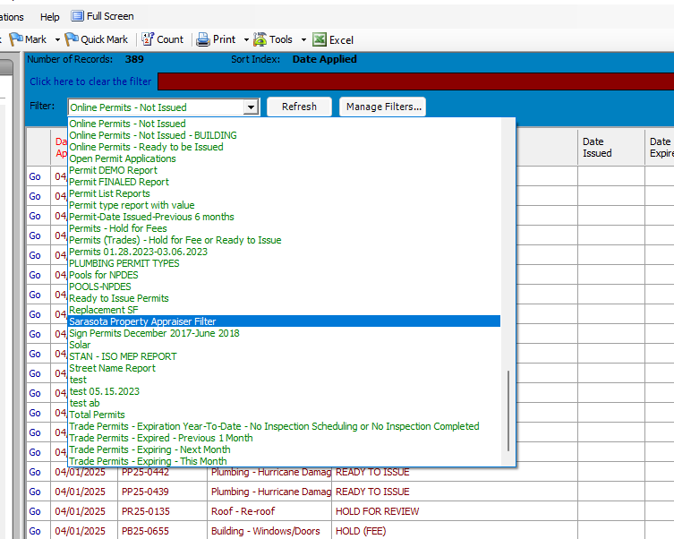
Manage Filters
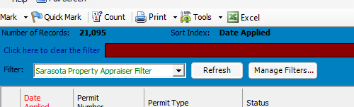
Date Issued-Change Date to the Last Day of Month
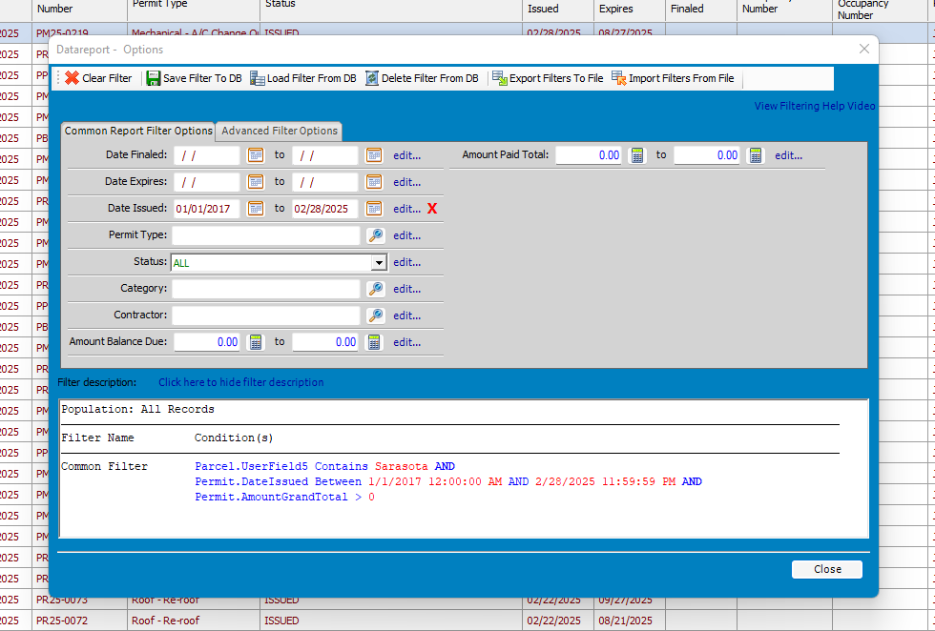
Click Close
Would you like to save your changes to filter ‘Sarasota Property Appraiser Filter’? Yes
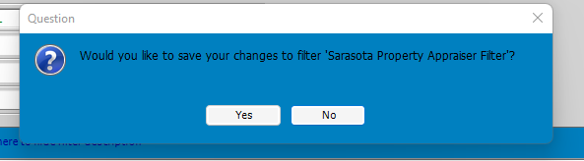
Go to Excel
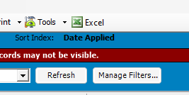
Title
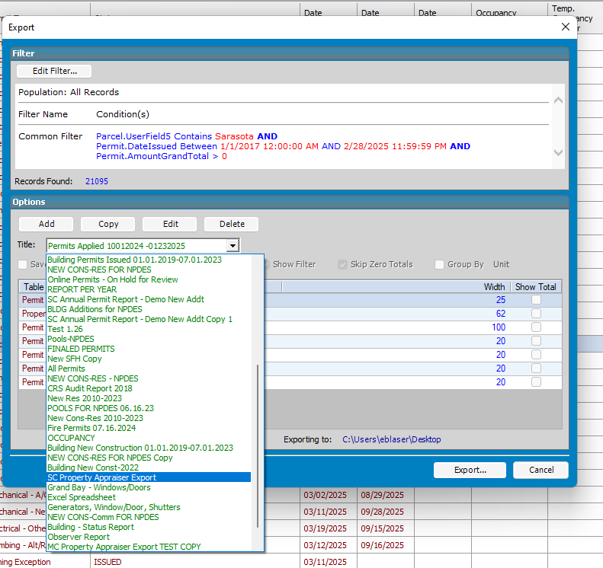
Click Export
In the Excel Document remove (delete) the 1st three rows
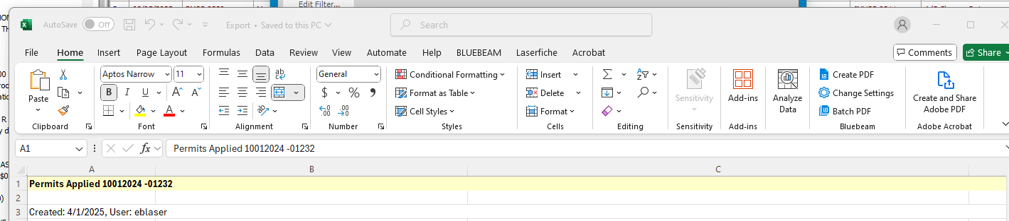
Save as LBKReports
Send e-mail to Sarasota Country Property Appraiser
