*EXPIRED PERMITS WAITING/PENDING*

**In good faith, your permit will remain in an active (non-expired) status until all necessary updates are completed on our end.**  
We sincerely appreciate your patience during this process

**PERMIT EXTENSION WORDS TO CONTRACTOR**

**Subject:** Permit Extension Approved – Permit #PB24-1355

Dear [Recipient's Name],

This is to confirm that the **second extension request** for **Permit #PB24-1355** has been **approved** by Building Official **Patti Fige**.

* **Original Expiration Date:** July 9, 2025
* **New Expiration Date:** August 9, 2025
* **Extension Period:** 30 days
* **Extension Fee:** $85.00

To finalize the extension, the required fee may be paid **online** or by \*\***calling our office 9413161966**

**\*\*(please have the permit#, address, credit card info, #, exp, cvv, name on card, email to send receipt)**

**\*\*\*HOW TO EXTEND PERMIT – BY PATTI FIGE \*\*\*\***

**After completing the attached, please go ahead and email the letter to me. Once received, your submittal will be forwarded to the Town of Longboat Key Building Official, Patti Fige, for review and approval.**

**Please note that while we are currently unable to provide a definitive timeline, all submittals are being reviewed as promptly and efficiently as possible**

1. CTRL F (PERMIT#) or F6 (address)

1. IF YOU HAVE TO ADD FEE $85

YOU GO TO TRANSACTIONS, RIGHT CLICK, ADD INVOICE,  FEE $85



1. Must ATTACH COPY OF the Approved signed letter by Building official

Right Click on the Permit #- Add to Permit - Attach External Document – Name “90 day permit extension”

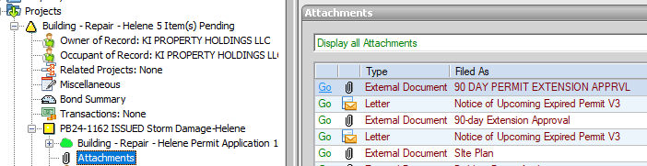

STIPULATIONS:

07-07- 2025 - PERMIT#PB24-1162   - EXTENDED FOR 90  DAYS. APPROVED BY BUILDING OFFICIAL - PATTI FIGE.

2ND PERMIT EXTENSION REQUEST. EXPIRED  (Originally exp date) 7/9/25

CHANGE EXPIRATION DATE - base on #of days approved by PATTI FIGE “DATE EXPIRES:”

