Longboat Key Canal Maintenance Assessment Program

WATERFRONT FEET ANALYSIS

Sample Neighborhoods | Waterfront Feet | Typical Assigned  Water Access Units
Buttonwood | 100 | 1
Bay Isles | 80 | 1
Harbour Court | 50 | 1
Country Club Shores | 100 | 1
Houses on Canals 4-6 | 100 | 1
Sample Small Vacant Lots | 45 | 1

 |  | Water Access  Units | Equivalent Residential Units (ERUs) based on Average Waterfront Feet
Sample Condo, HOA and Non-Residential | Waterfront Feet | Based on  Boat Slips,  Boat Docks,  Boat Lifts | @ 50 ft. | @ 80 ft | @ 100 ft
Docks on the Bay Condo  20 Condo Units  16 Boat Slips | 427 | 16 | 8.54 | 5.34 | 4.27
Boathouse on Longboat  194 marina dry racks  9 wet boat slips | 205 | 203 | 4.1 | 2.56 | 2.05
Laguna Yacht Village HOA  10 Boat Slips | 298.1 | 10 | 5.96 | 3.73 | 2.98
Harbour Villa Club at the Buccaneer  30 Condo Units  38 Boat Slips | 837.2 | 38 | 16.74 | 10.46 | 8.37
Grand Mariner of Longboat Key  14 Condo Units  34 Assigned Boat Slips | 377.9 | 34 | 7.56 | 4.72 | 3.78

Docks on the Bay Condo
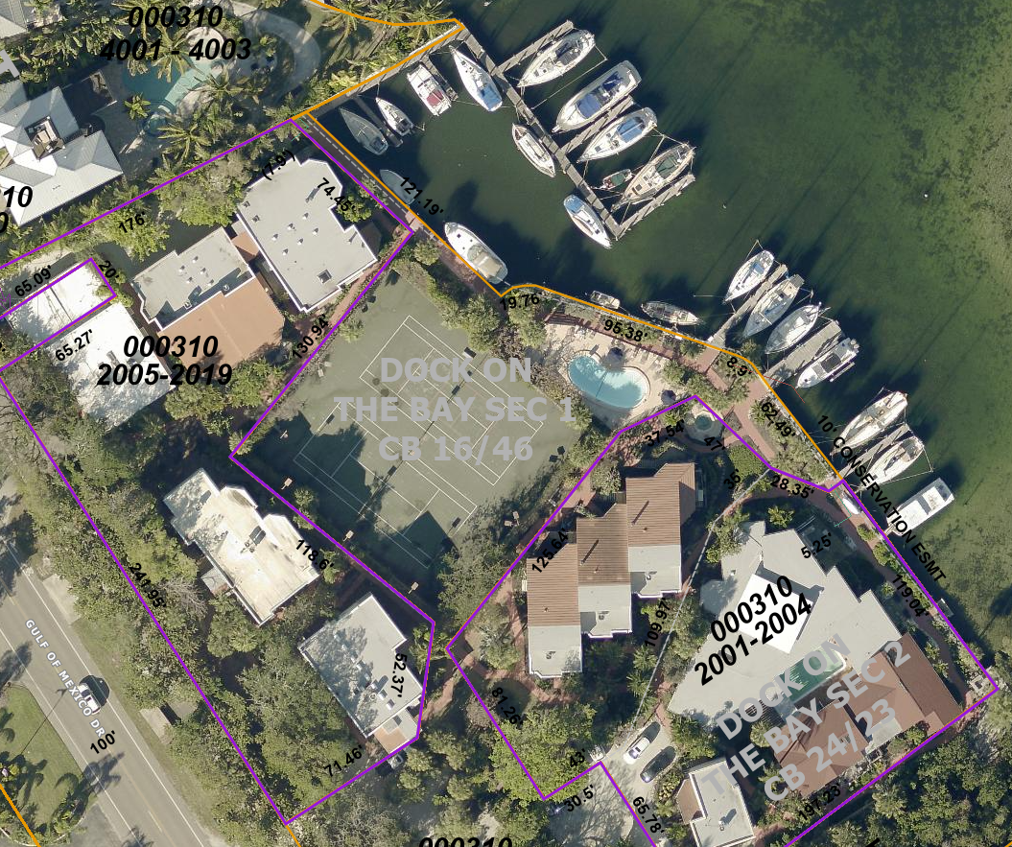
Boathouse on Longboat
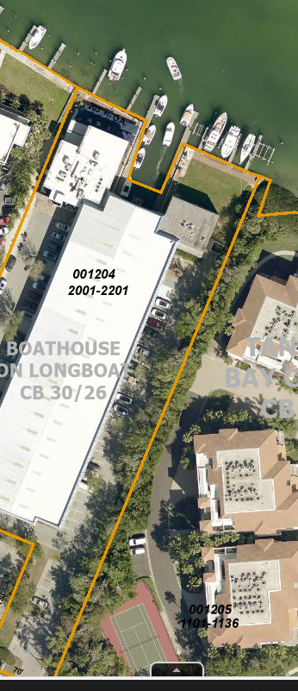

Laguna Yacht Village HOA
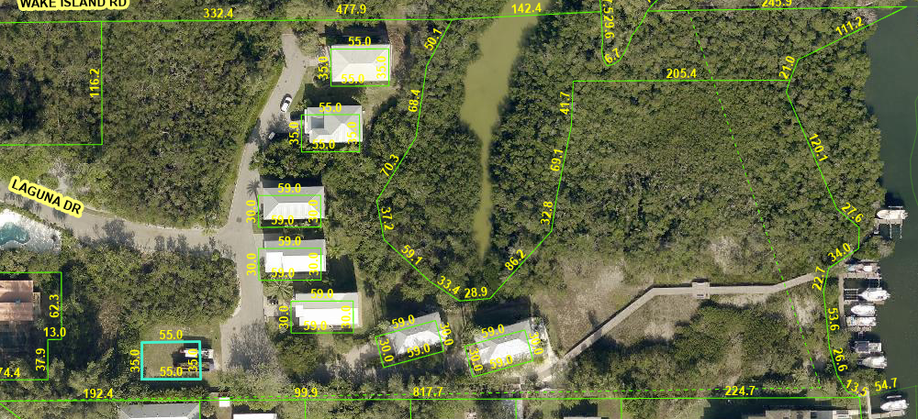

Harbour Villa Club at the Buccaneer
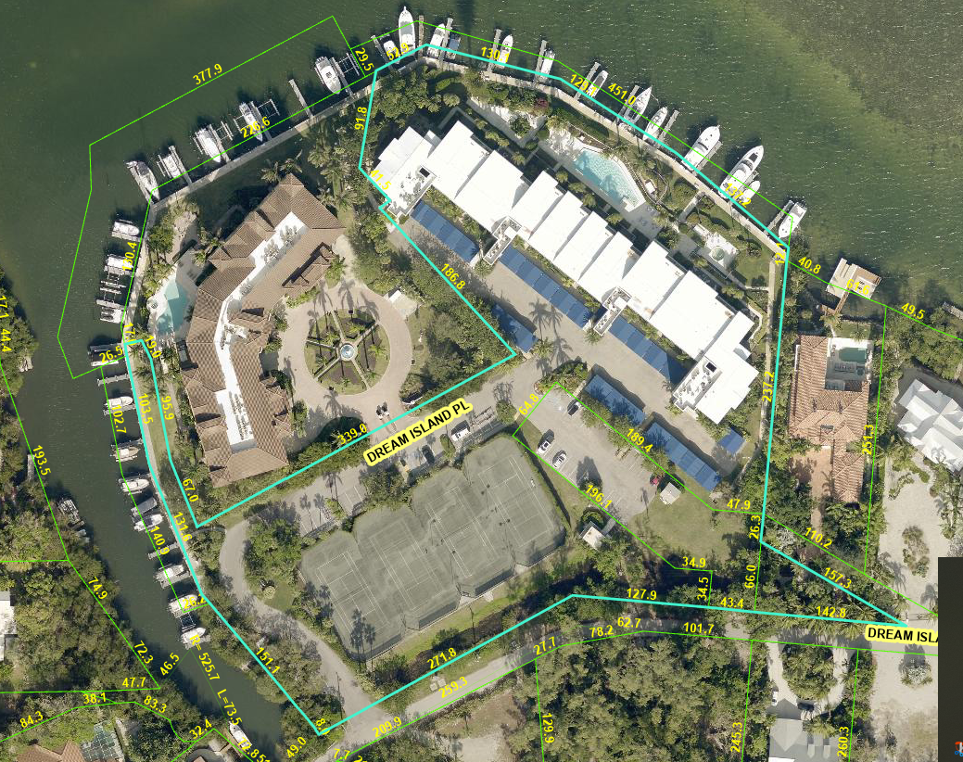
Grand Mariner of Longboat Key
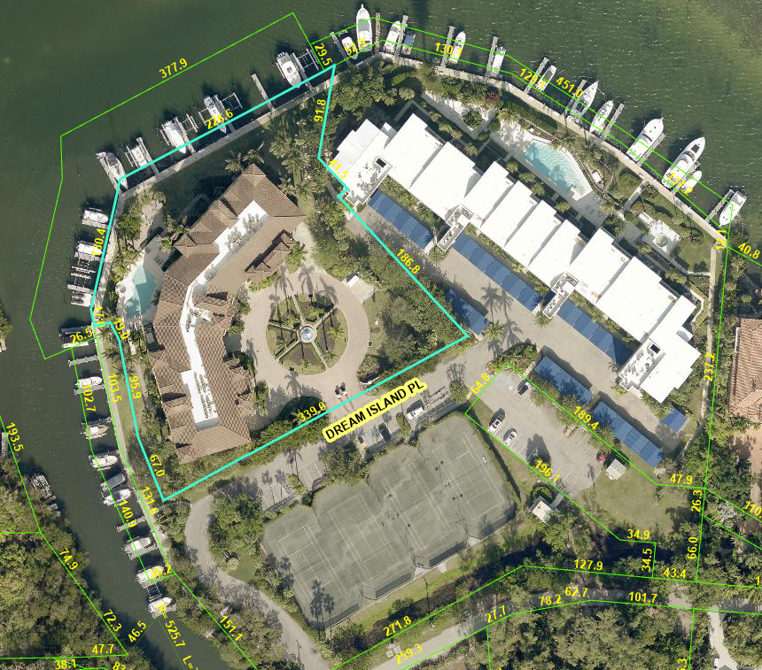

Single Family Residential Neighborhood Samples
Buttonwood
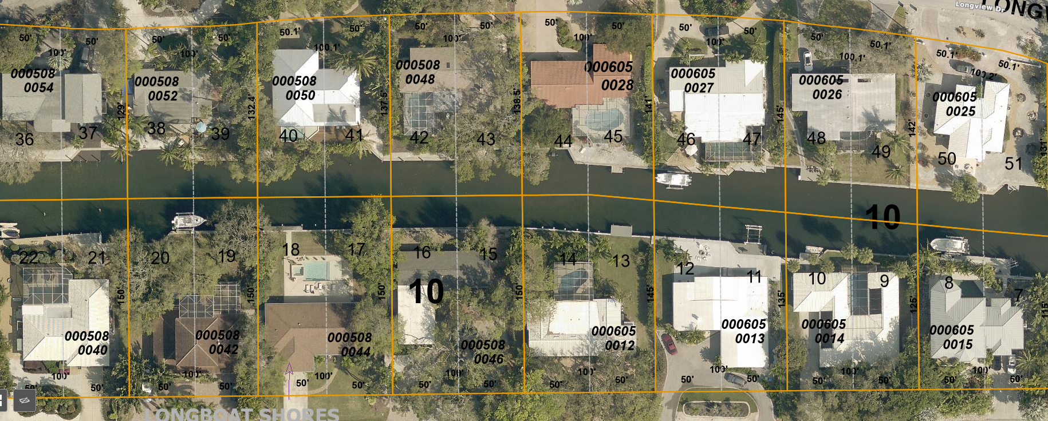

Bay Isles
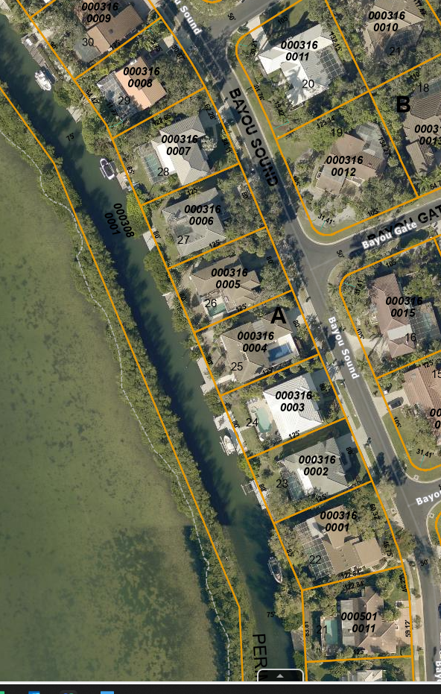

Harbour Court
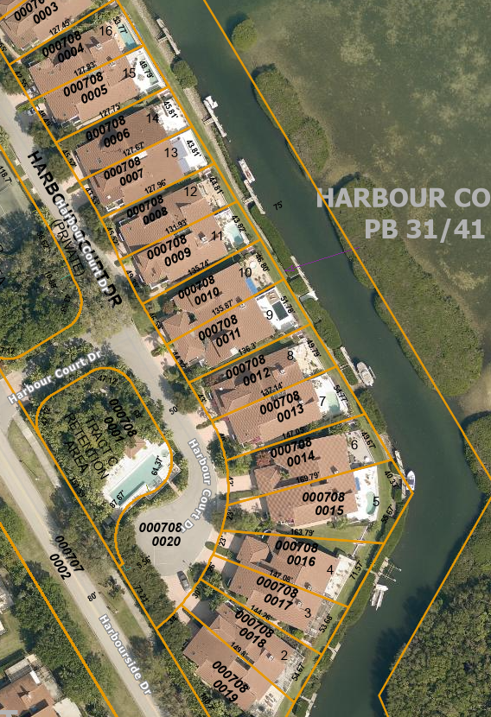

Country Club Shores
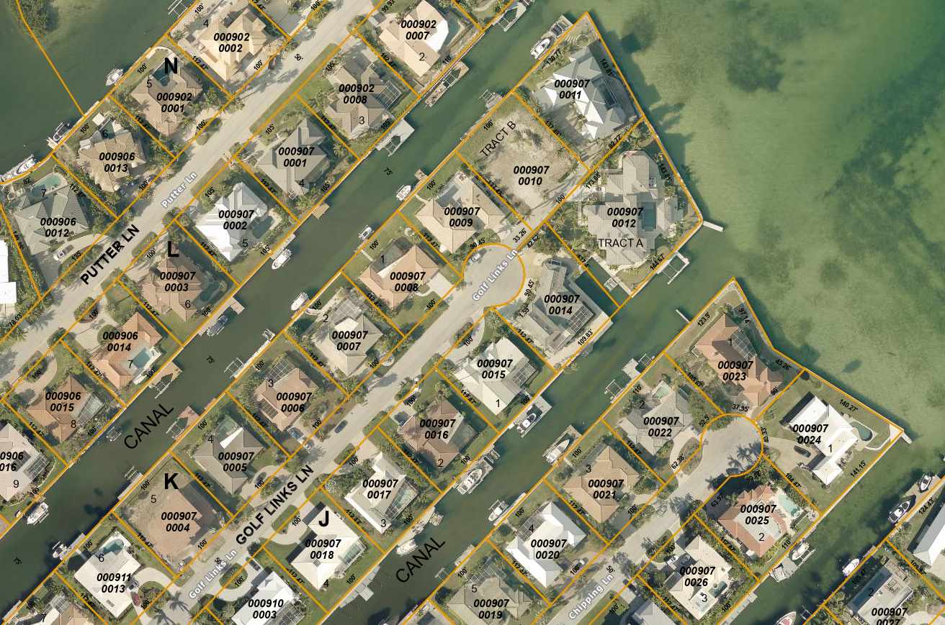

Canals 4-6
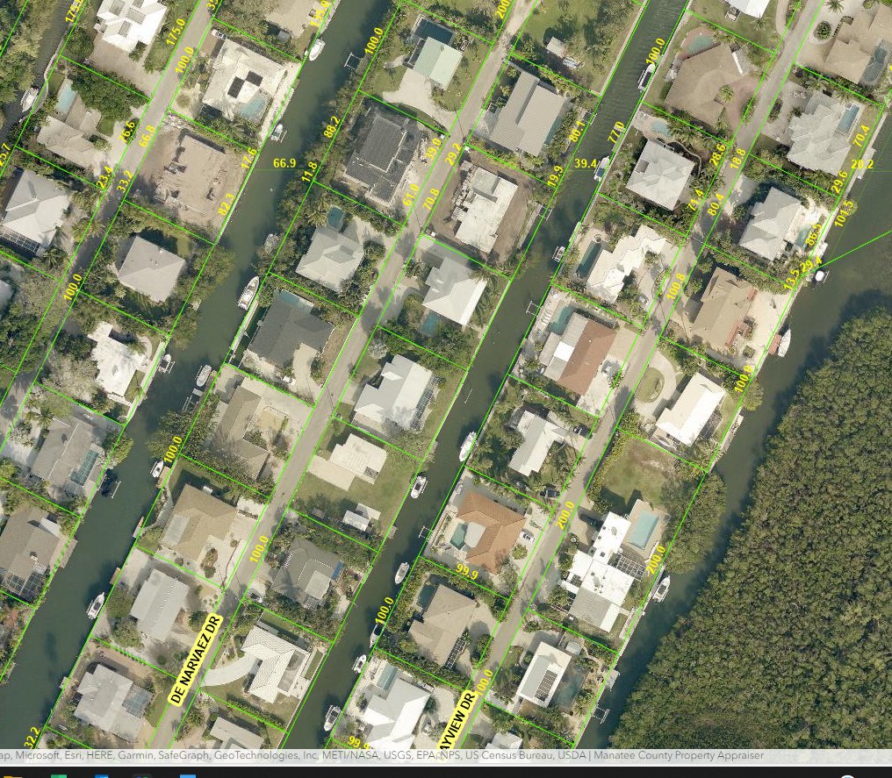

Small Vacant Lots
