Longboat Key

Canal Maintenance Assessment Program

Who will be charged?

* All parcels that are abutting the blue and green canals.

How will the parcels be charged?

* We will assign water access units based on the actual or allowable number of boat slips, docks and lifts; with a minimum of 1 water access unit for each abutting parcel.
  + Vacant parcel = 1 water access unit
  + Vacant parcel with boat slip = 1 water access unit

**1**

**1**

**1**

**1**

**1**

* + Parcel with house and no boat slip = 1 water access unit

**1**

* + Parcel with house and boat slip = 1 water access unit

**1**

* + Parcel with house and 2 boat slips = 2 water access units

**2**

* + Condo Complex with 26 boat slips
    - 26 water access units ÷ 102 condo units = .2549 water access units each

Example: Whitney Beach Condo

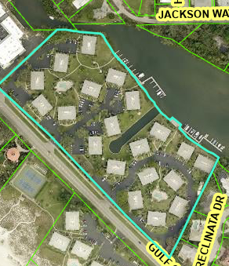

26 slips ÷ 102 condos = .2549 each