NATURAL GAS PERMIT - HOW IT WAS DONE IN BS&A – PERMIT PP24-0222

FEE FOR PERMIT $119 - INVOICE LP GAS SYSTEM, BPR PERMIT CERT, DCA – PERMIT SURCHARGE.

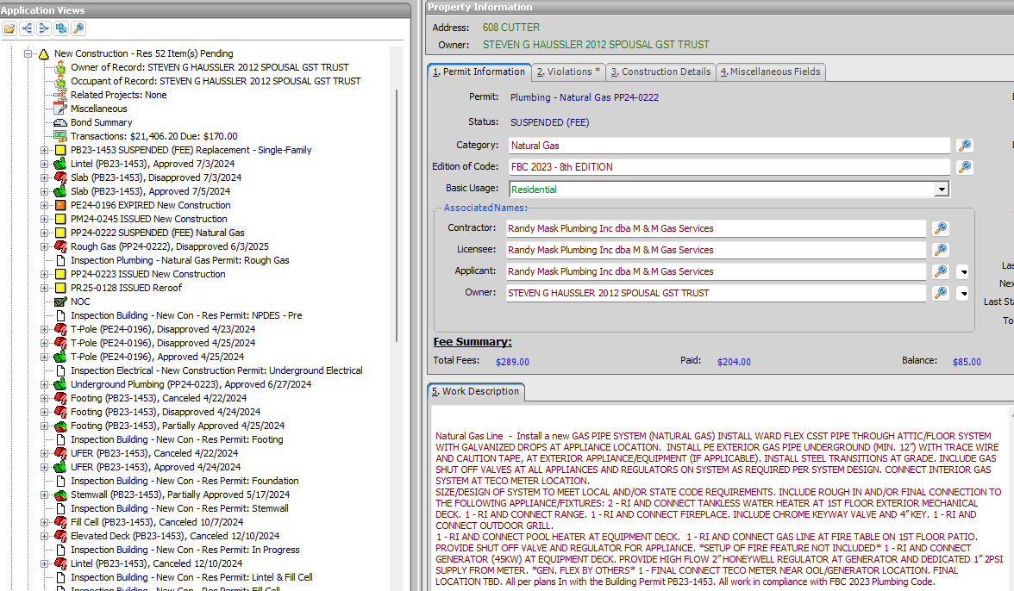

T-POLE - PE24-0196 - New SF-Install all electrical for the new single family residence per the plans. In accordance with the Building Permit PB23-1453

