Manatee County Reports-Done every Monday unless there is a Holiday-Tuesday or Friday
3. Permit Table
Choose MC Property Appraiser Filter
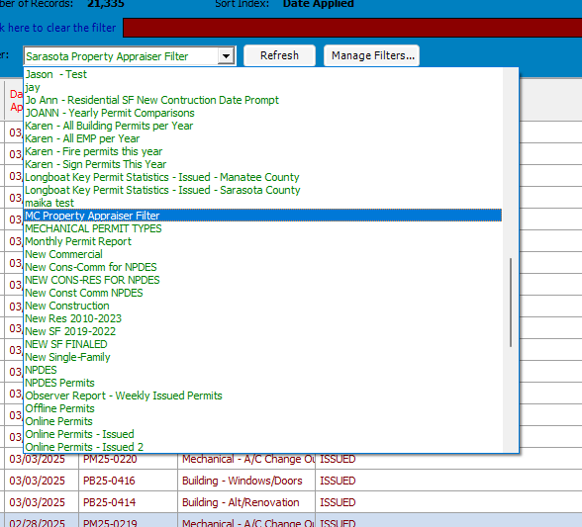
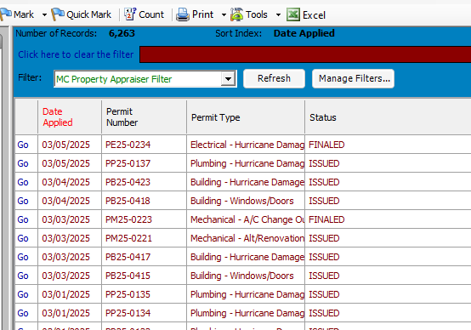
Go to Excel
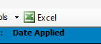
Title-MC Property Appraiser Export
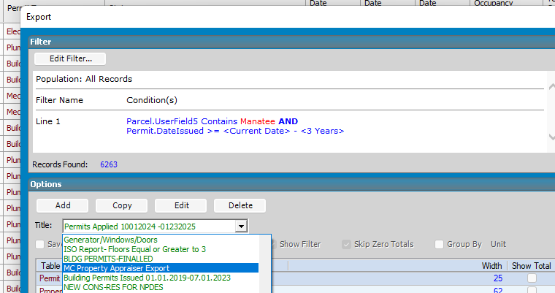
Click Export
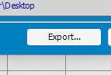

Rename It to lbkexport
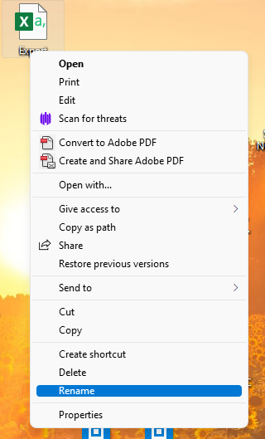
Open Core FTP LE
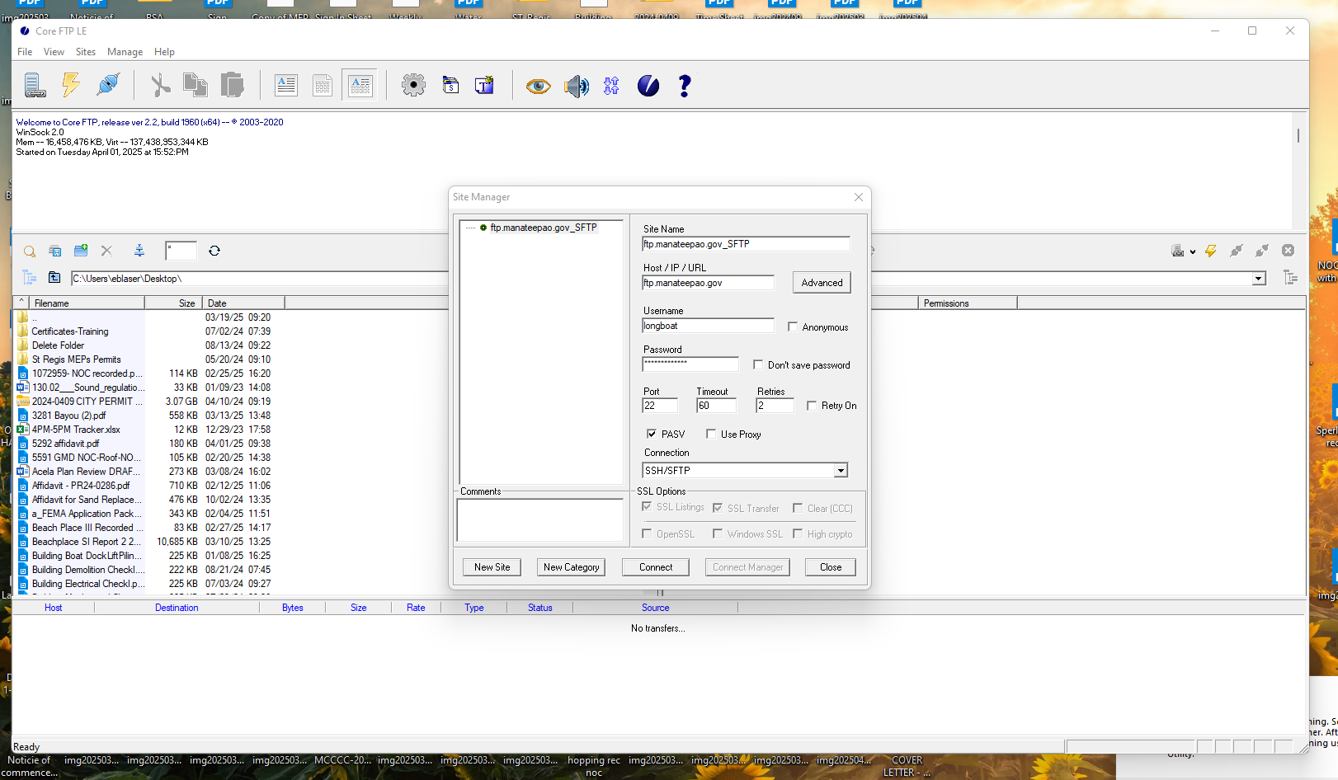
Click Connect

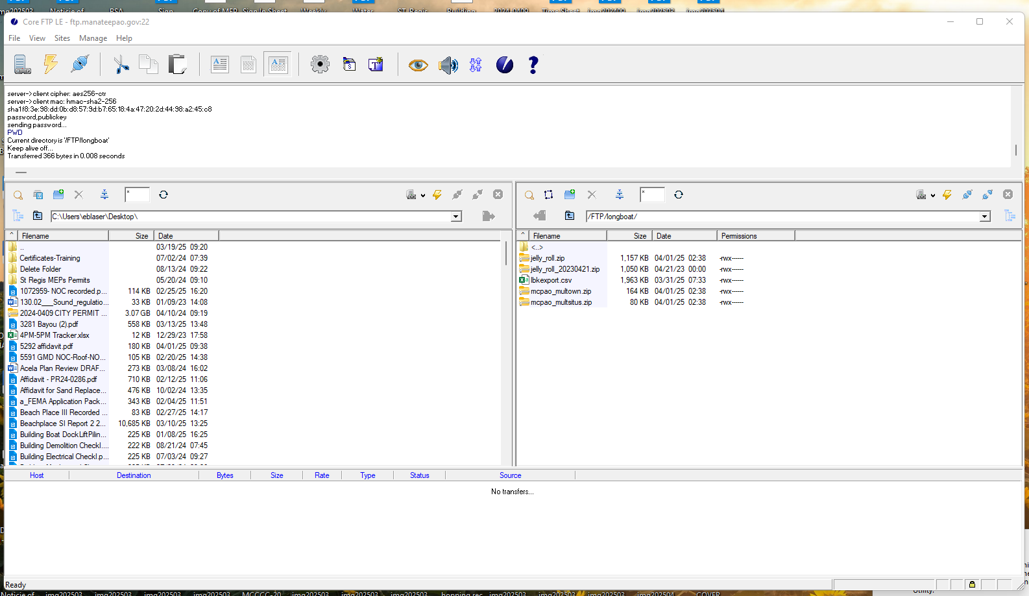
Make sure you highlight in the left column the lbkexport.csv
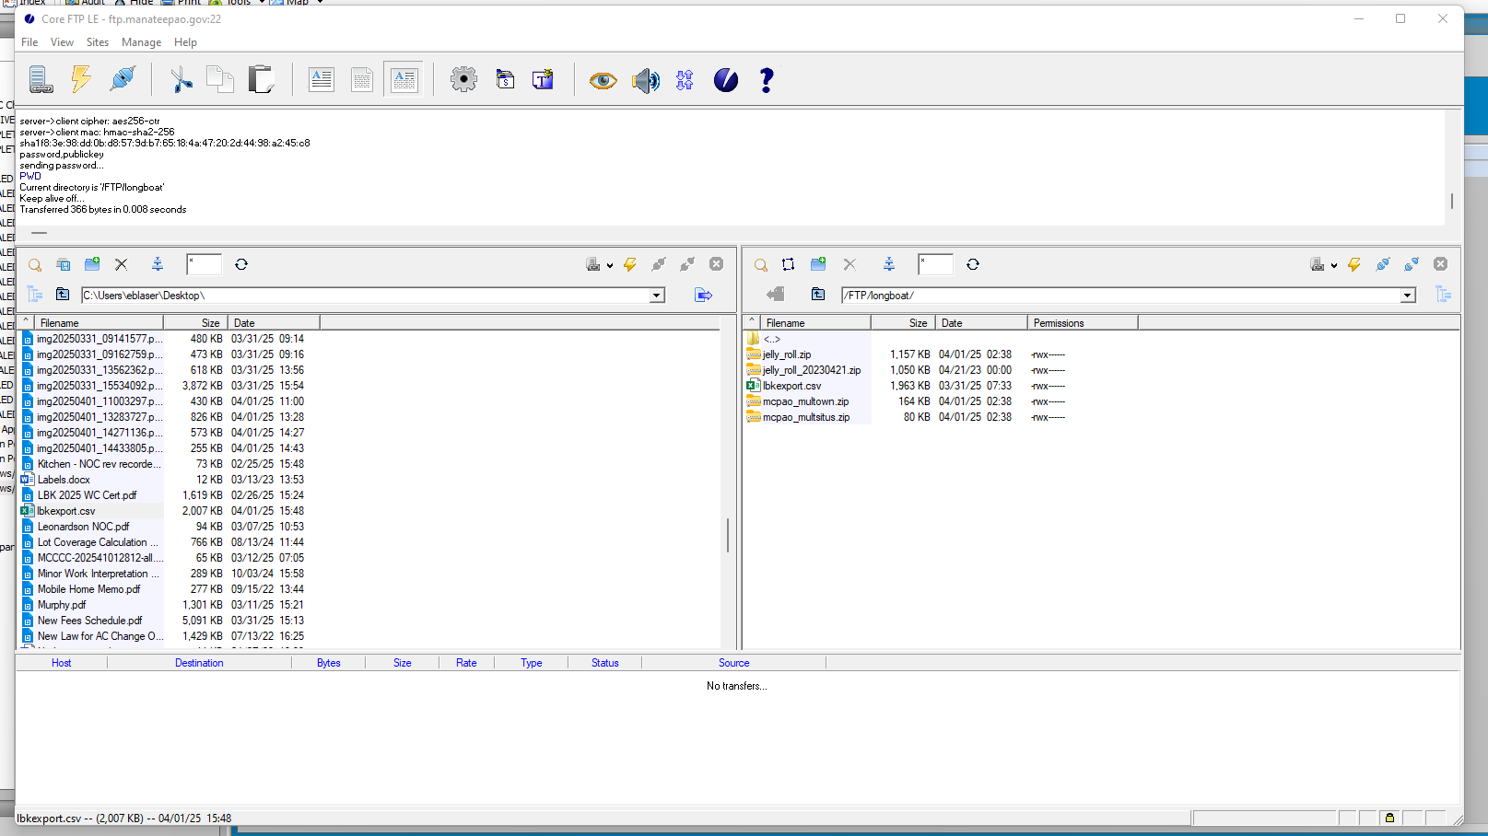
Upload-
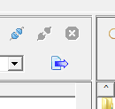
Overwrite All
