Send documents to Contractor from Link
Ctrl+F (Permit Number)
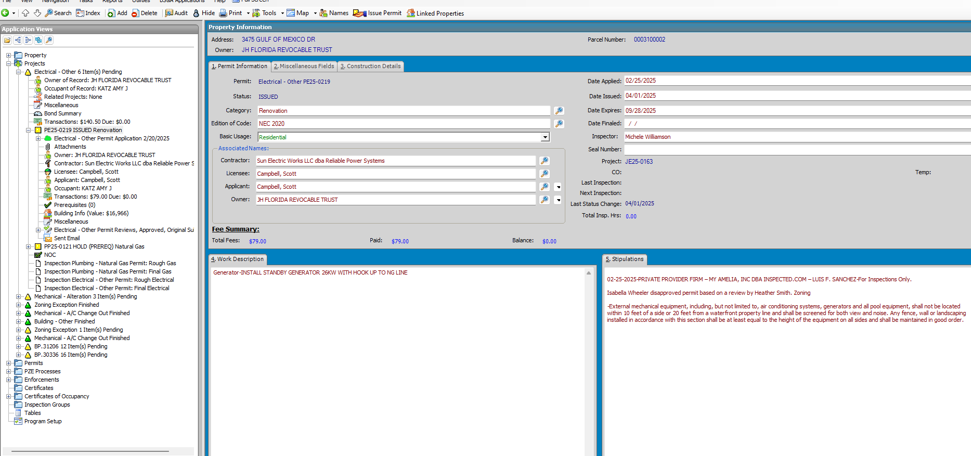
Electrical-Other Permit Reviews
Click +
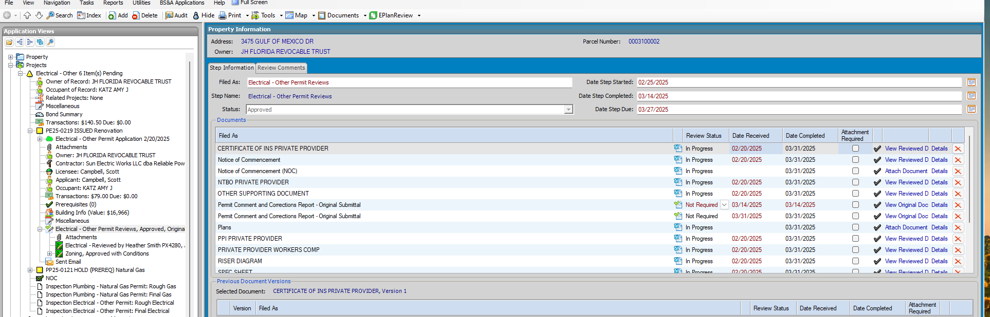
Under Documents
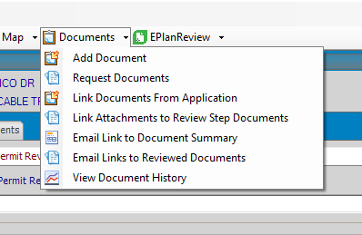
E-mail Link To Document Summary
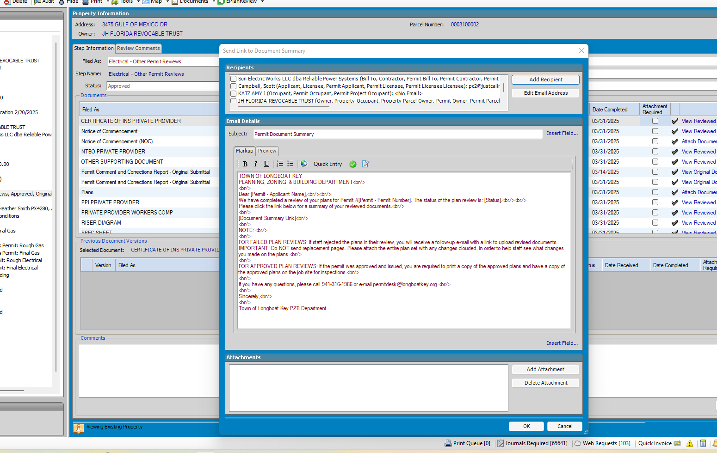
Choose the 1st E-mail Recipients
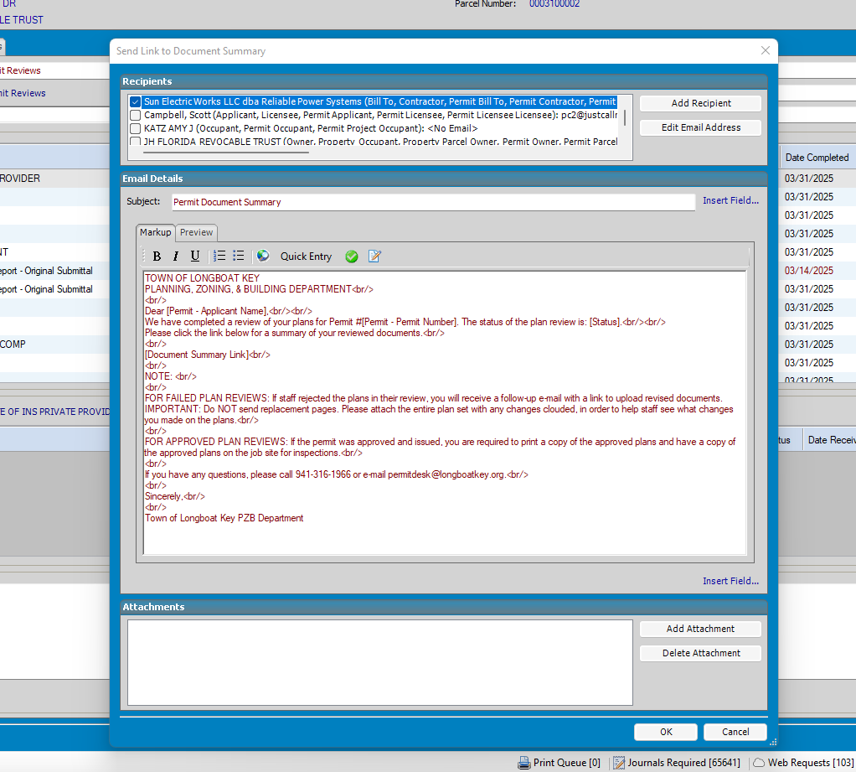
Click OK

