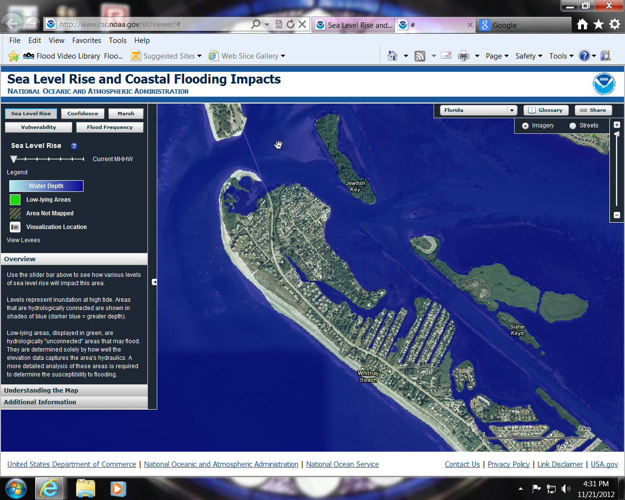
Town Of Longboat Key North End and Village
Normal High tide and sea level
Coastal Flooding Impacts
Based on National Oceanic & Atmosphere Administration
water depth predictions
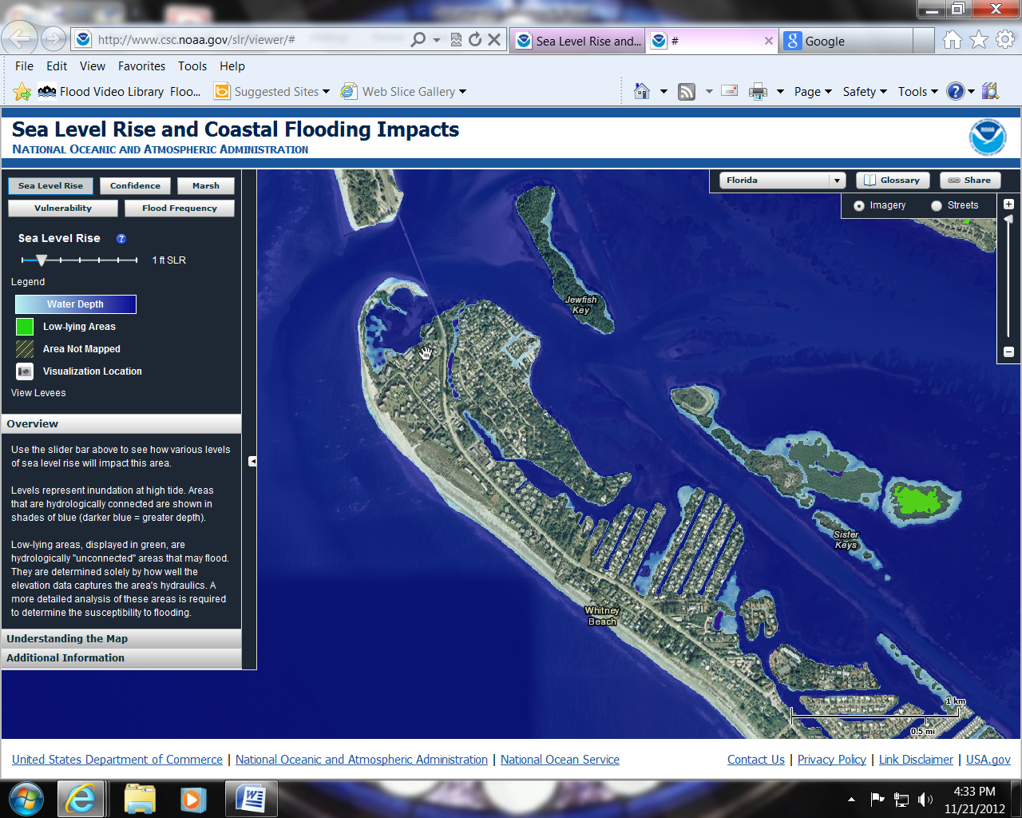
Town Of Longboat Key North End and Village
Normal High tide and + 1 foot sea level rise
Coastal Flooding Impacts
Based on National Oceanic & Atmosphere Administration
water depth predictions
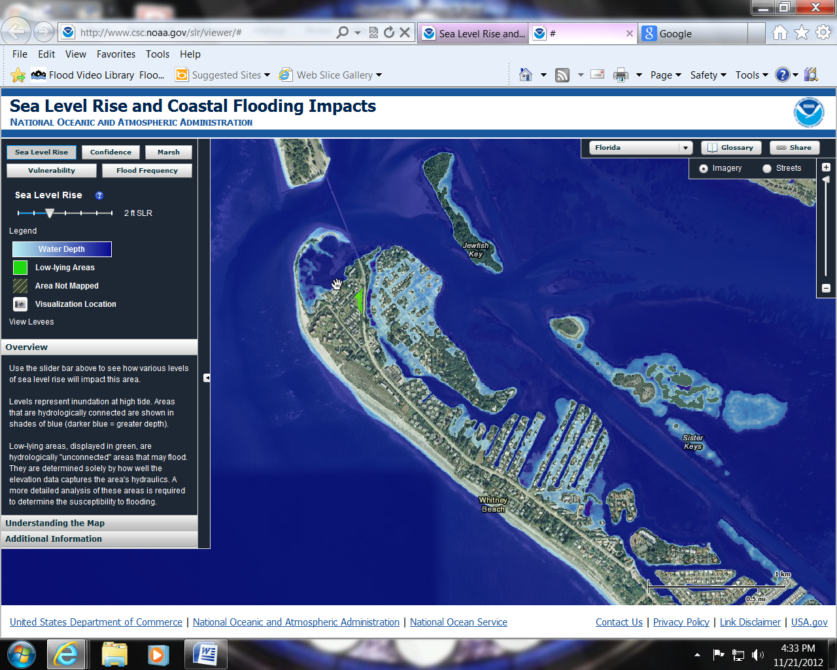
Town Of Longboat Key North End and Village
Normal High tide and + 2 foot sea level rise
Coastal Flooding Impacts
Based on National Oceanic & Atmosphere Administration
water depth predictions
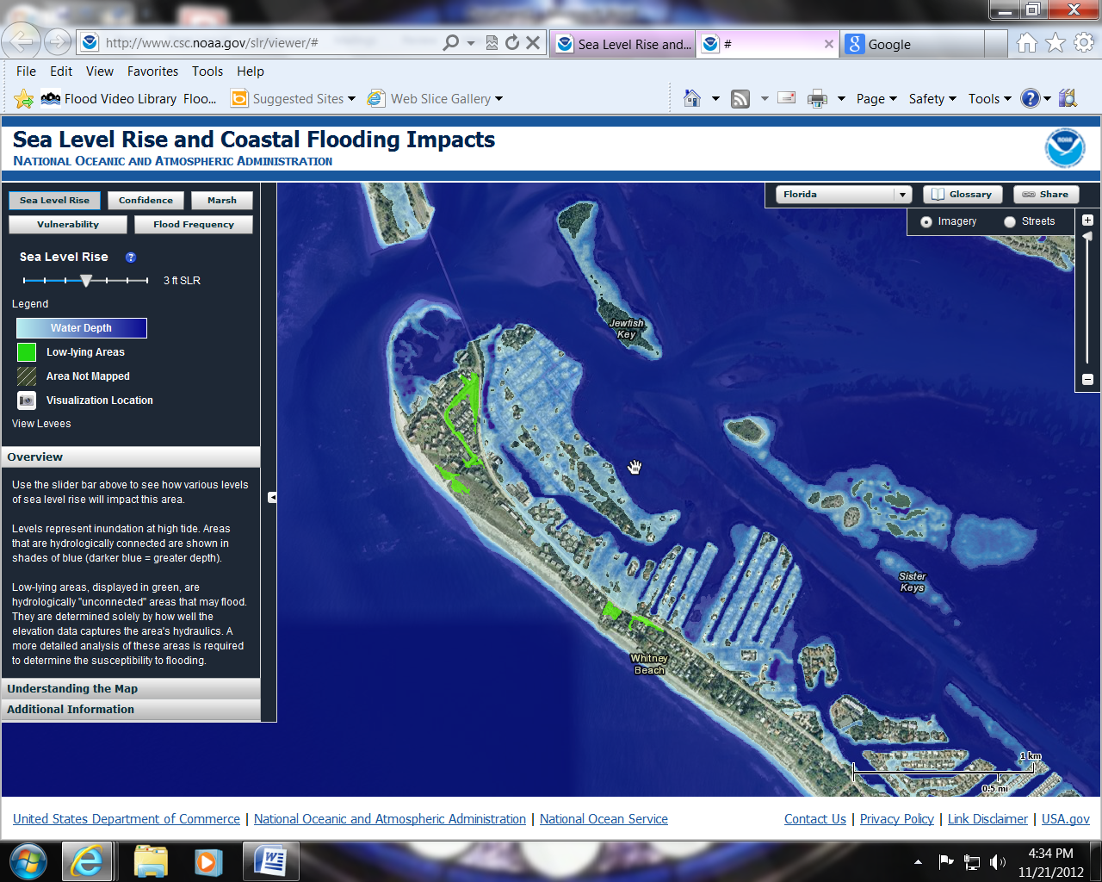
Town Of Longboat Key North End and Village
Normal High tide and + 3 foot sea level rise
Coastal Flooding Impacts
Based on National Oceanic & Atmosphere Administration
water depth predictions
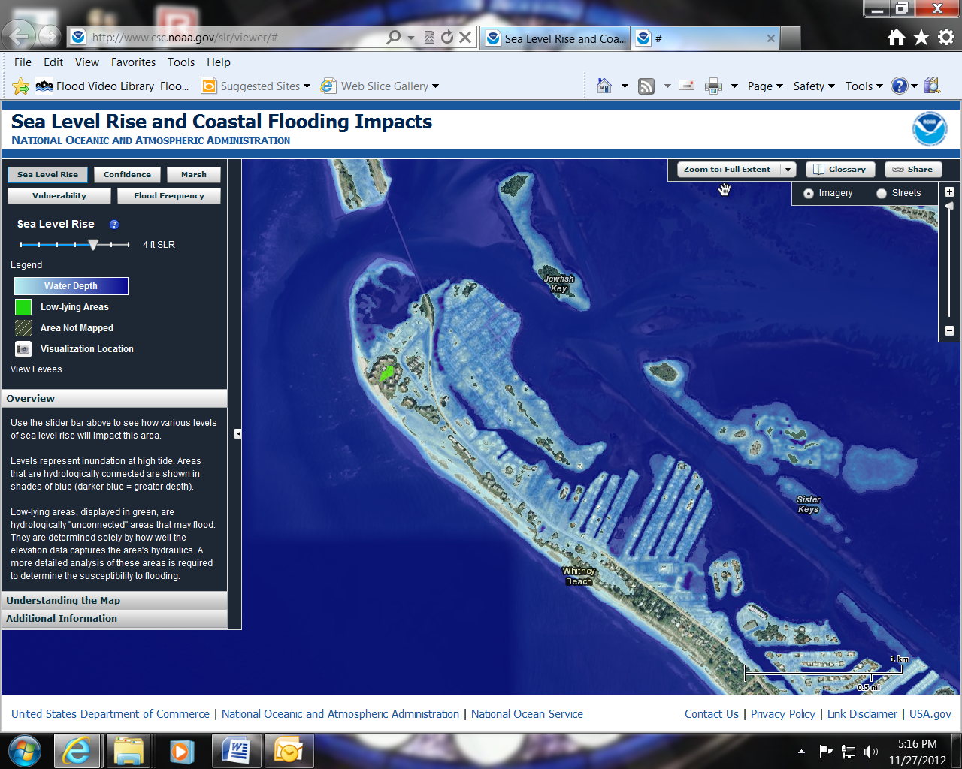
Town Of Longboat Key North End and Village
Normal High tide and + 4 foot sea level rise
