Village Parking Pictures
March 14, 2014 approx. 6:15pm
Provided by Pete Rowan

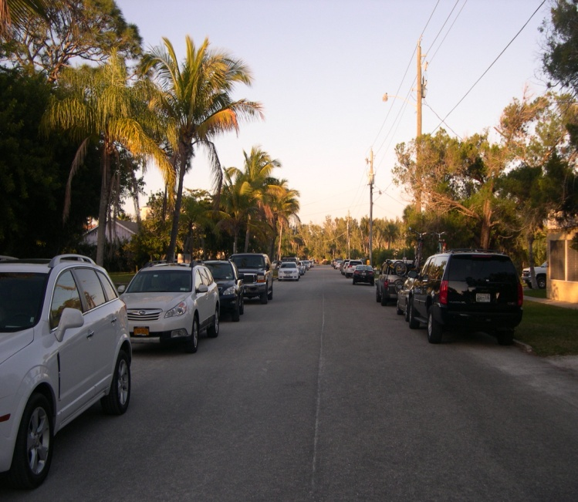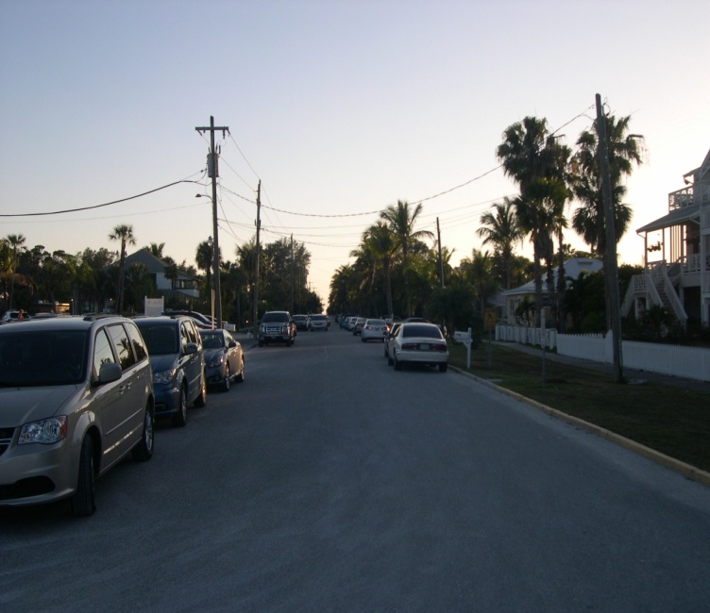
Broadway Looking East Broadway Looking West

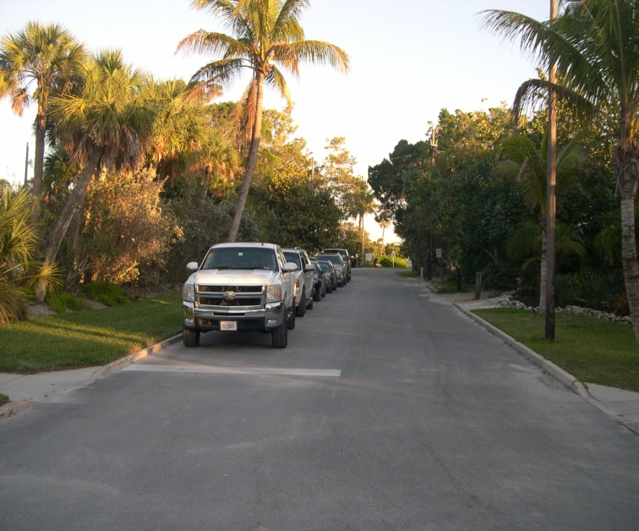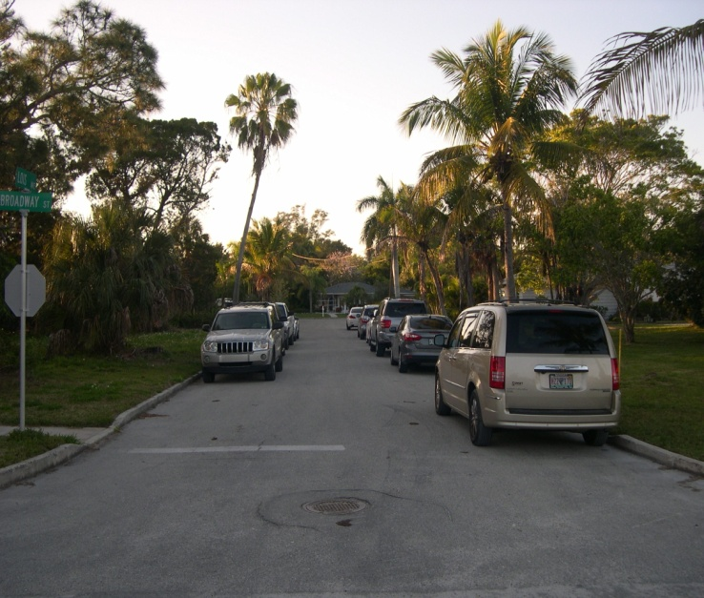
Lois Looking South Lois Looking North

