September 29, 2014
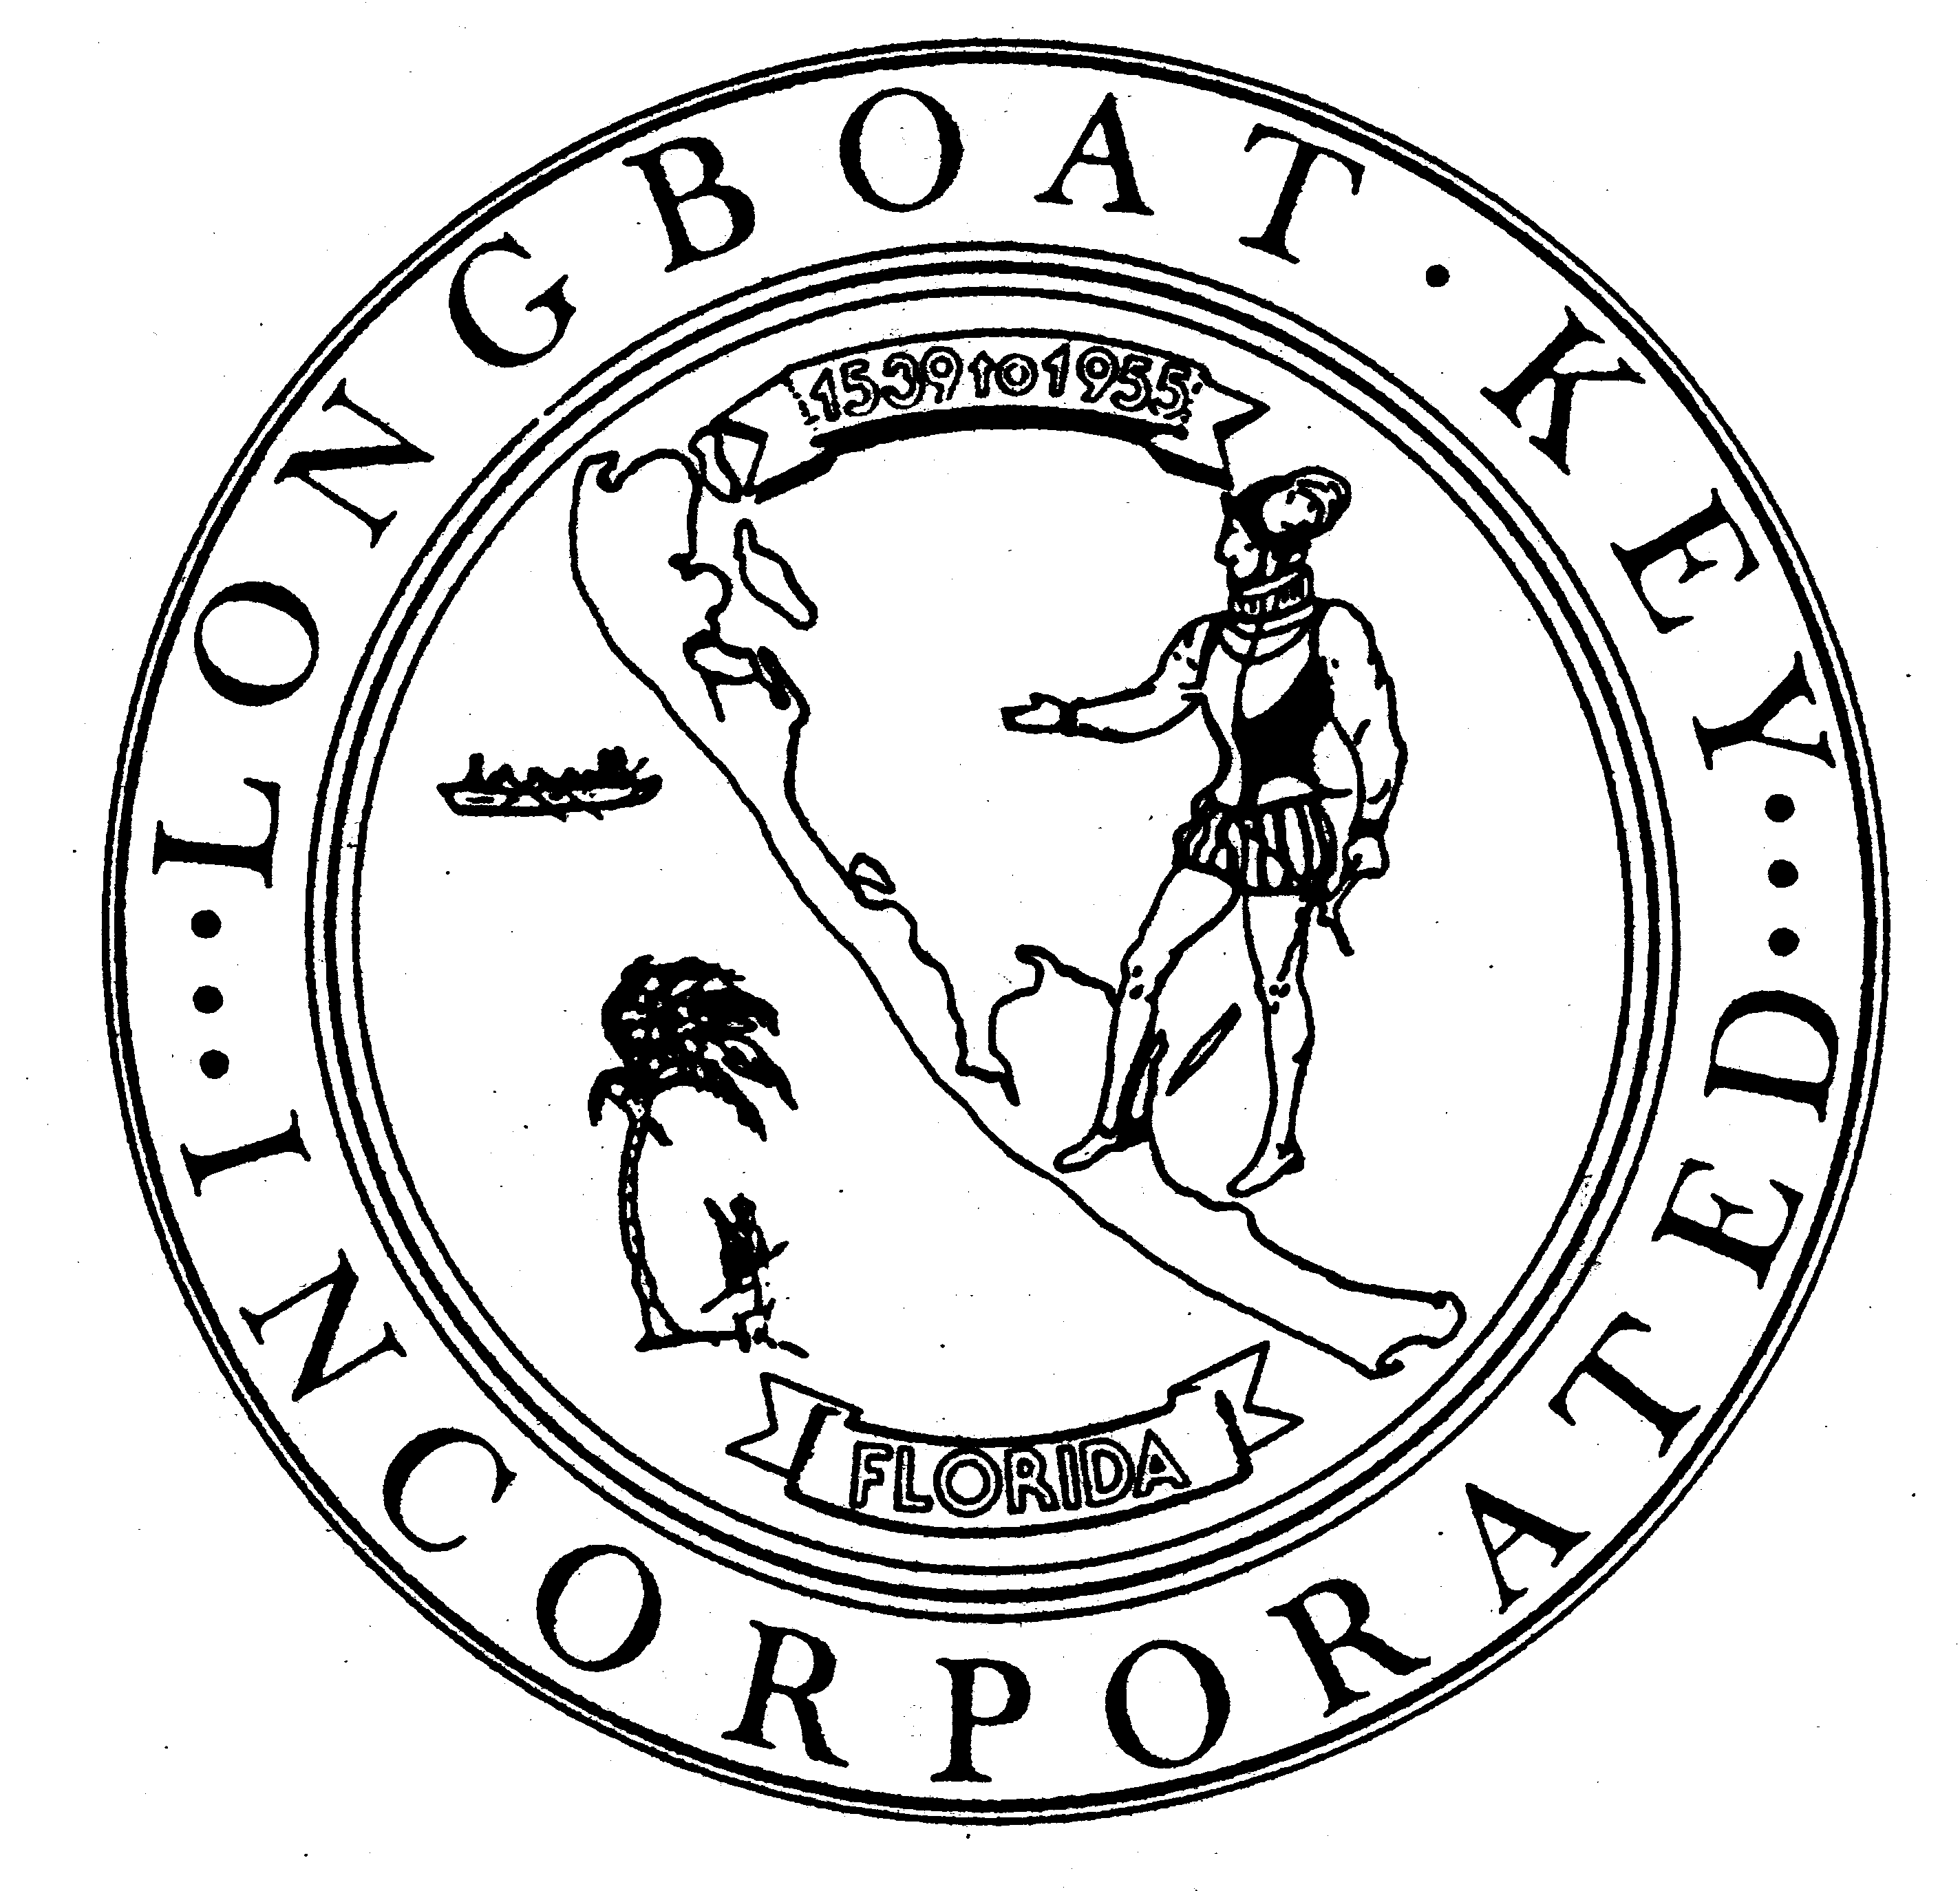

Public Works Department

600 General Harris Street
Longboat Key FL 34228
(941) 316-1988
FAX (941) 316-1984
www.longboatkey.org

TOWN OF

Longboat Key

Incorporated November 14, 1955

Name
Address
Longboat Key, FL 34228

Re: Village Parking – October 6, 2014 Town Commission Meeting, 7PM
Ordinance 2014-31, Amending Chapter 74, Parking Schedules

Dear Village Resident:

The Town Commission will meet on October 6, 2014 at 7PM for their Regular Meeting. The agenda for this meeting includes the discussion of a proposed ordinance that will change parking regulations in the Village based upon previous changes to the parking regulations and discussions with Village residents and business owners. Ordinance 2014-31 is on the agenda for first reading. Input from the public, especially from Village property owners, is encouraged. Pending Commission action on October 6, this Ordinance may be forwarded for adoption at the November 3, 2014 Commission meeting.

You can view, read and/or print the October 6, 2014 agenda and materials associated with this item online at http://www.longboatkey.org/agendalist.aspx?cid=9695. We invite you to attend this meeting and participate in the discussion.

Please call me at 941-316-1988 with any questions you may have.

Thank you,

Juan Florensa
Public Works Director

c. Mark Richardson, Streets, Facilities, Parks & Recreation Manager
Anne Ross, Assistant Town Manager
Susan Phillips, Assistant to Town Manager

