Regular Workshop – December 12, 2016
Agenda Item # ??

Agenda Item: Update of the Village Stormwater System Evaluation and Analysis

Presenter: Public Works Director, DMK Associates

Summary: The Town procured the services of DMK Associates, to conduct an evaluation and assessment of the stormwater system in the Historic Longbeach Village on the north end of the island. This evaluation includes determination of the level of service provided by the existing system and to make recommendations to improve the performance of the overall drainage system for the Village.

Attachments: 12-5-16 Memo, Public Works Director to Town Manager;
November 2016, DMK Associates Report, Longboat Key Village Stormwater Evaluation and Alternative Analysis

Recommended
Action: For information only.

Memorandum
Date: December 5, 2016
TO: Dave Bullock, Town Manager
FROM: Juan Florensa, Public Works Director
SUBJECT: Update on the progress of the Village Stormwater System Evaluation and Analysis

The Town procured the services of DMK Associates, to conduct an evaluation and assessment of the stormwater system in the Historic Longboat Village on the north end of the island. This evaluation includes determination of the level of service provided by the existing system and to make recommendations to improve the performance of the overall drainage system for the Village.

BACKGROUND

As a result of a study conducted in 2002, the Town performed drainage improvements to alleviate flooding in the Village. Improvements included the construction of stormwater pipes, drainage inlets, manholes and Tideflex® valves designed to assist in keeping tidal waters from entering the stormwater system.

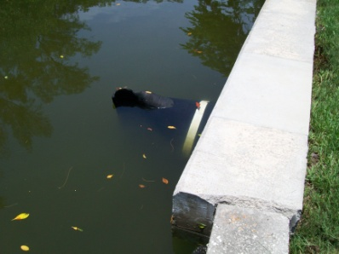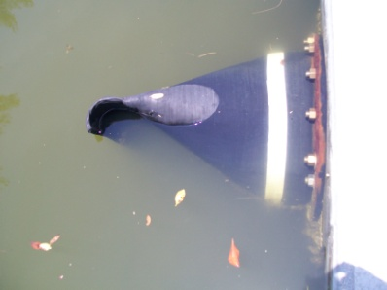
Sample picture of valve

The design level of service for the project was to keep the crown of the local streets clear from stormwater during a 10 year 24-hour rain event (7 inches) coinciding with a tide elevation of 1.5 feet. Although the project helped to improve the historic flooding problems, there are portions of the Village that continue to hold water during high tides and rain events.

DMK Associates was asked to evaluate the performance of the existing stormwater system and make recommendations to the Town of Longboat Key to determine potential solutions for this nuisance flooding.

Kreg Maheu, PE, DMK Associates, is prepared to provide a PowerPoint presentation and discuss the attached report and Evaluation and Alternatives Analysis.

