Durante Park Property
Property Line Location

Adjacent to St. Judes Drive South

Durante Park

Durante Park Property
Property Line Location

Adjacent to St. Judes Drive South

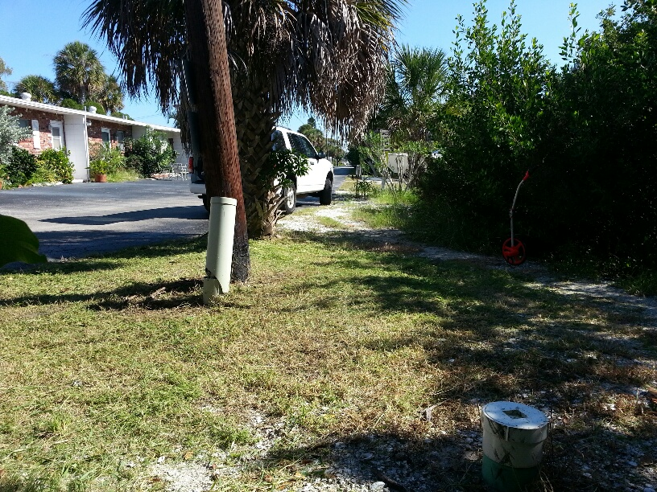
80 feet from seawall per plat map

Looking from corner of Durante Park and 644 St Judes Dr. (southeast corner) towards the east. (Could not find Iron rod #1876 +1.84’ft. identified on Landry & Esber survey of 1994), adjacent grade is approx. +3ft. found rubble mound.

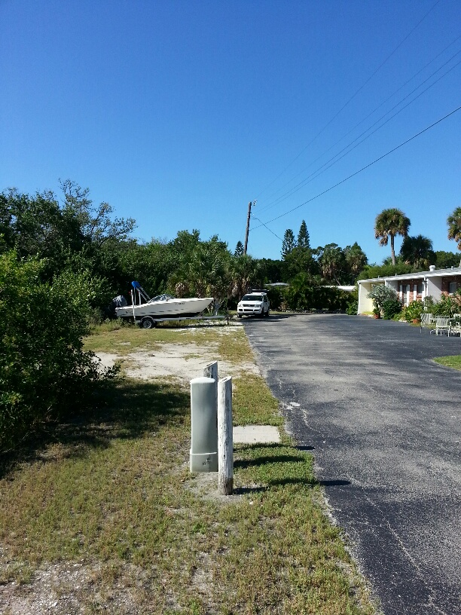
80 feet from seawall per plat map

Looking west from first Verizon (GTE) pedestal. Measurement from seawall matches pedestal found on Landry & Esber survey of 1994.

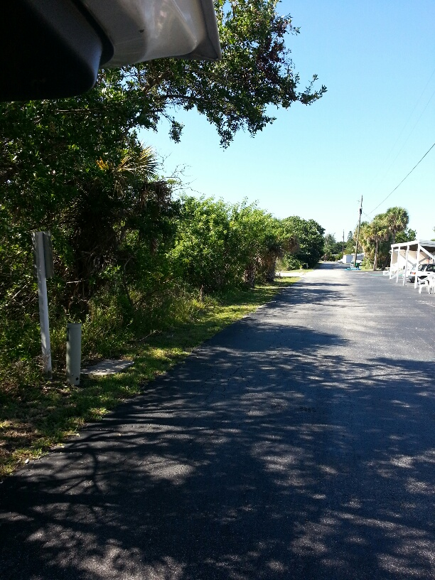
80 feet from seawall per plat map

Looking west from third Verizon (GTE) pedestal. Measurement from seawall matches pedestal found on Landry & Esber survey of 1994.

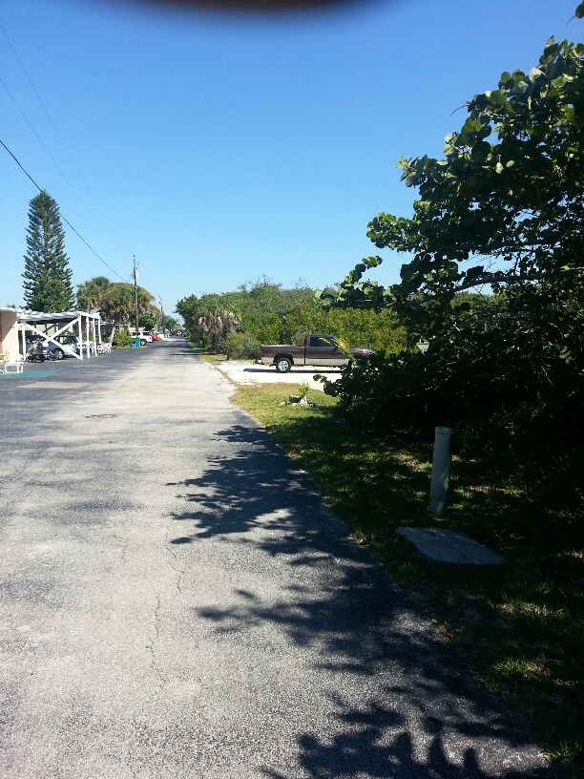

Looking east from third Verizon (GTE) pedestal by Fire Hydrant. Approximate location of property line found on Landry & Esber survey of 1994.

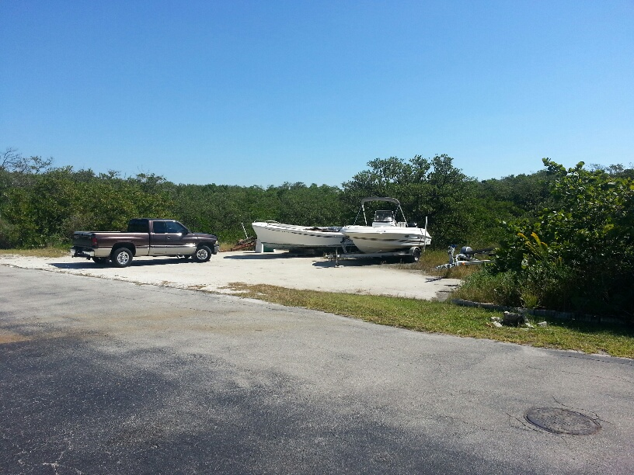

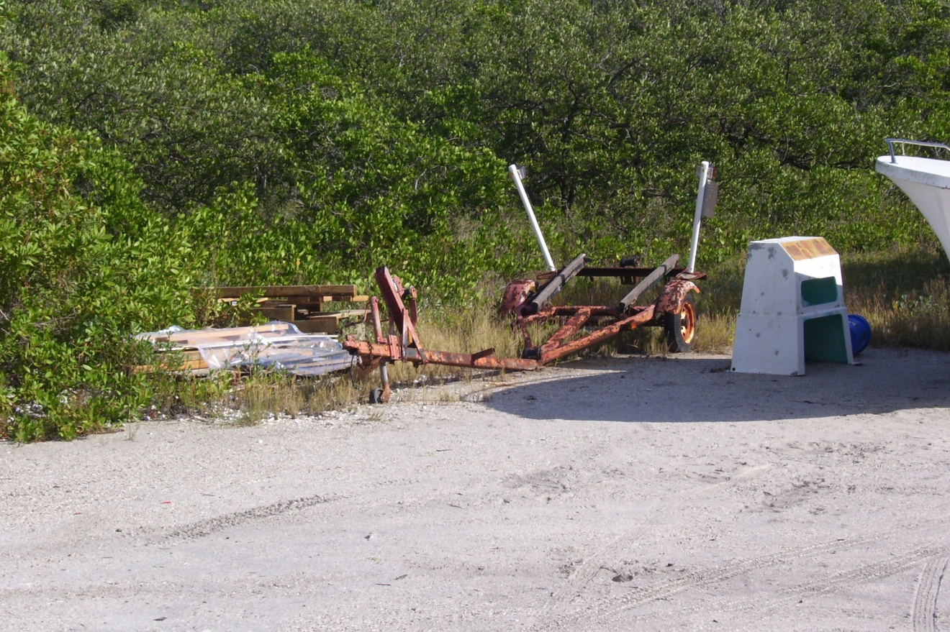

Looking south from east of third Verizon (GTE) pedestal by Fire Hydrant. Approximate location of property line found on Landry & Esber survey of 1994.

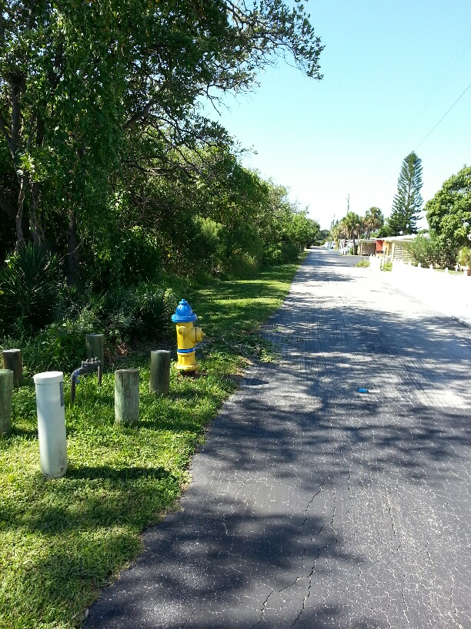
80 feet from seawall per plat map

Looking west from fourth Verizon (GTE) pedestal by Fire Hydrant. Measurement from seawall closely matches pedestal found on Landry & Esber survey of 1994.

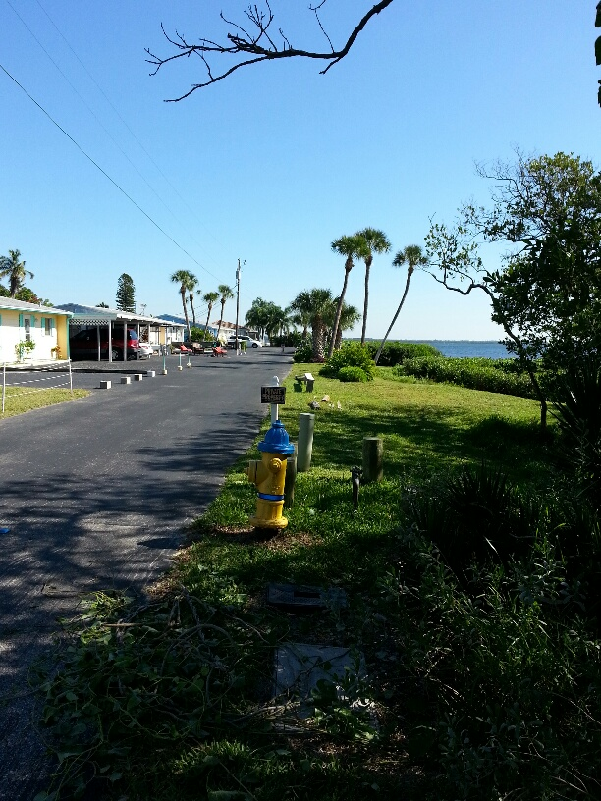
80 feet from seawall per plat map

Looking east from fourth Verizon (GTE) pedestal by Fire Hydrant. Measurement from seawall closely matches pedestal found on Landry & Esber survey of 1994.

