Town of Longboat Key
Longbeach Village Alleys
Public Utility Map

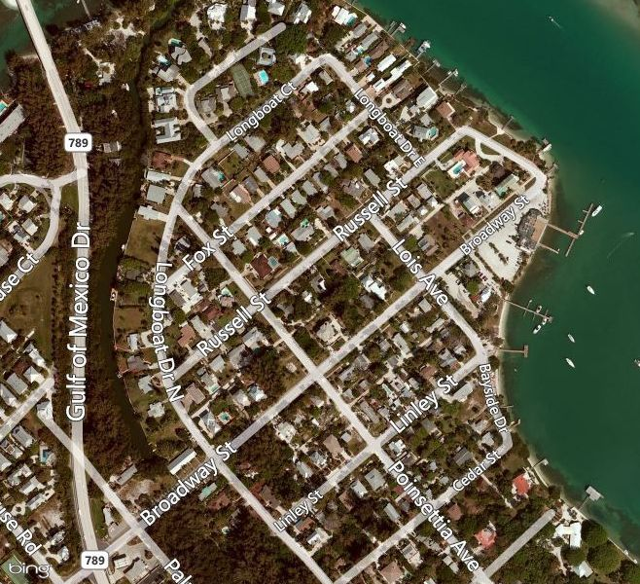
Alley#3
Alley#2
Alley#1

Red: represents FPL Overhead (primary and secondary voltage lines)
(Note: poles also have Comcast Cable TV)

Green: Represents Underground Waste Water lines.

Yellow represents Underground Gas utility; (TECO Peoples Gas)

Blue represents Underground Stormwater

Town of Longboat Key
Longbeach Village Alleys
Public Utility Map

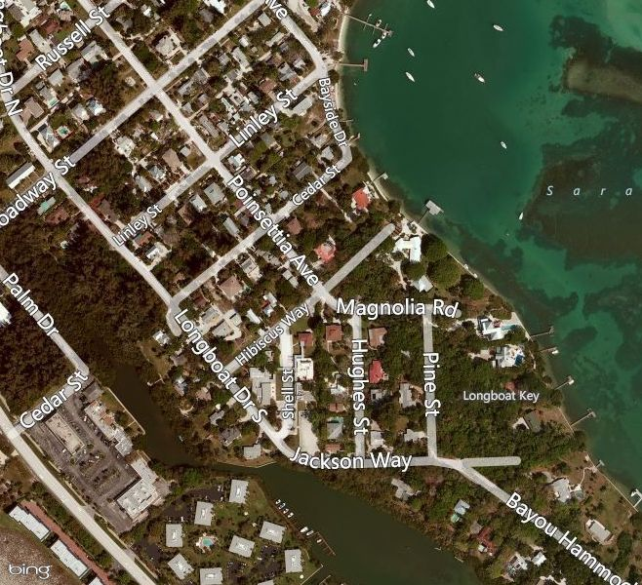
Alley#7
Alley#5
Alley#6
Alley#4

Red: represents FPL Overhead (primary and secondary voltage lines)
(Note: poles also have Comcast Cable TV)

