Town of Longboat Key
Bay Accesses

- 800 Russell Street
This is a 50ft wide by 50ft strip of land providing excellent access with no parking.

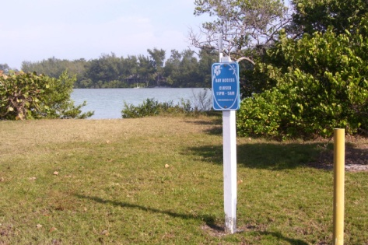

- 899 Broadway Street
This is a 50ft wide by 15ft strip of land providing very narrow access with approximately five parking spots.

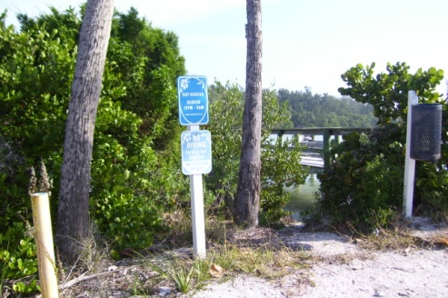

- 755 Linley Street
This is a 15ft wide by 10ft strip of land providing excellent pedestrian, kayak and boat access with approximately five shared parking spaces with the boat ramp. The dock provides a great fishing spot with a sink and filleting area.

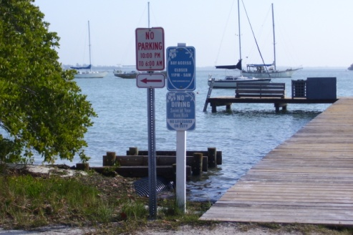

- 6930 Bayside Drive
This is a 50ft wide by 20ft strip of land adjacent to the Town boat ramp (See above) providing excellent access with no parking.

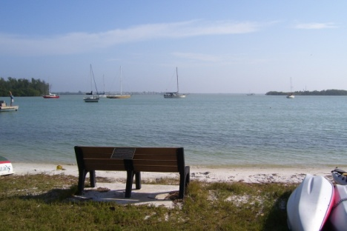
- 700 Cedar Street
This is a 50ft wide by 20ft strip of land. This parcel is heavily vegetated with mangroves hindering any access. For all practical purposes, this access is unusable for the intended purposes.

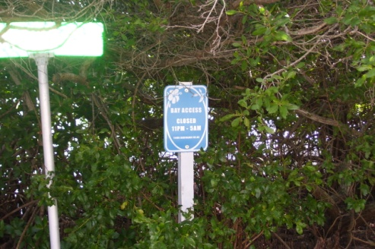

- 695 Hibiscus Way
This is a 50ft wide by 378ft strip of land. This parcel is heavily vegetated with mangroves, Brazilian peppers, palms and other plants hindering any access. There appears to be a dirt driveway encroaching on this parcel. For all practical purposes, this access is unusable for the intended purposes. Removing the invasive trees would not make this anymore accessible.

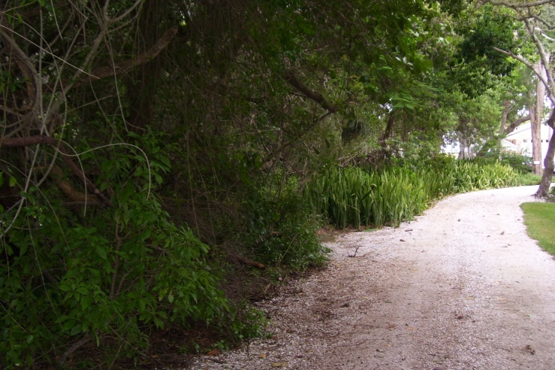

695 Hibiscus Way

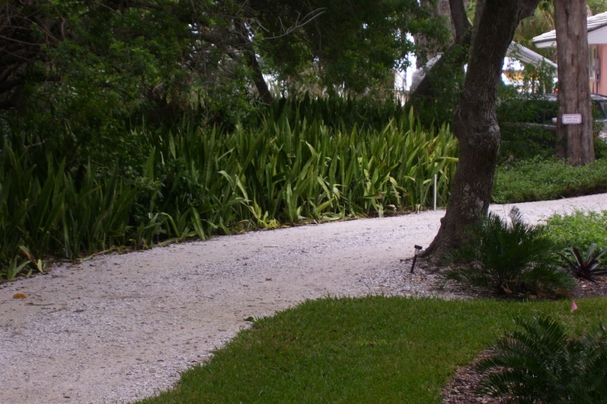

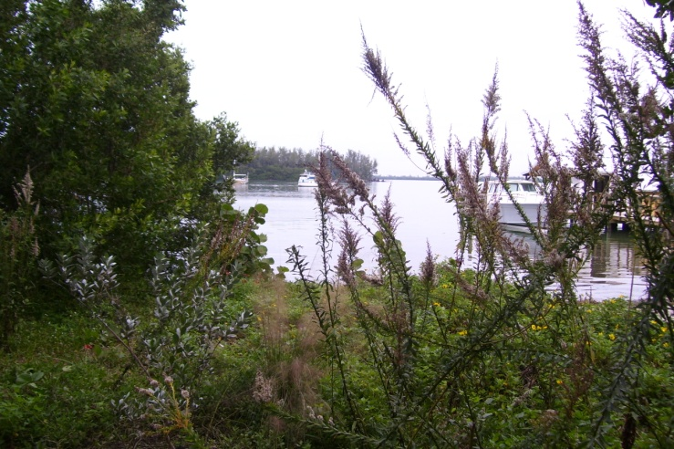

695 Hibiscus Way

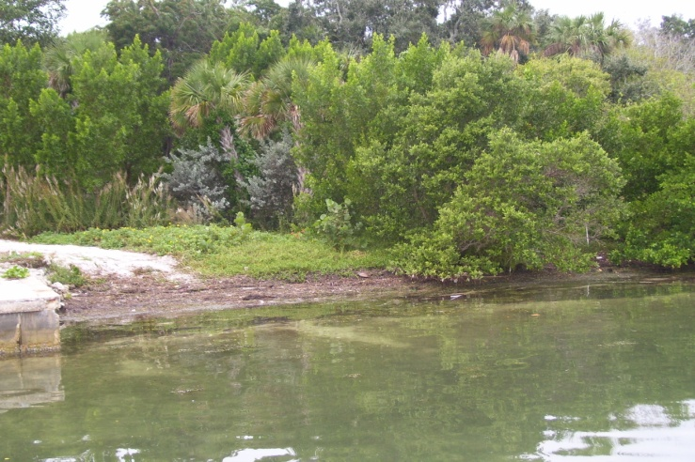

- 6800 Longboat Drive South
This is a 50ft wide by 8ft strip of land fringed by mangroves providing minimal access with no parking.

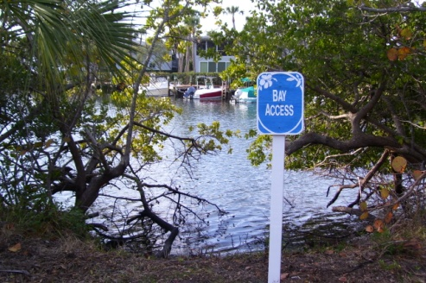

- 755 Magnolia Road
This is a 50ft wide by 290ft strip of land providing excellent access with approximately three parking spots. The actual width of this access narrows considerably at water’s edge due to the mangroves.

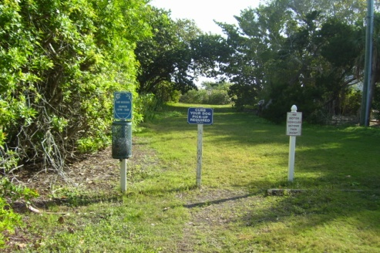

- 755 Jackson Way

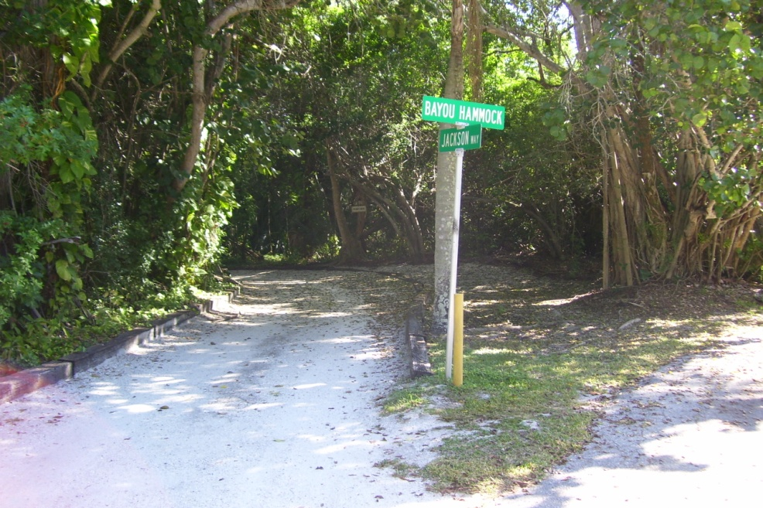

755 Jackson Way

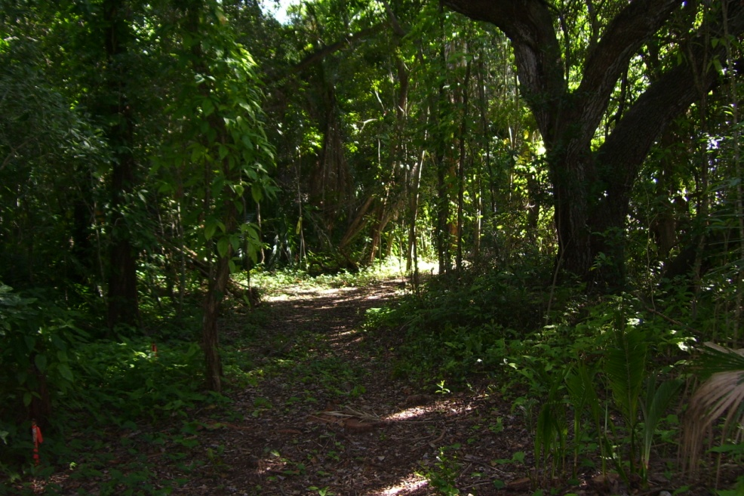

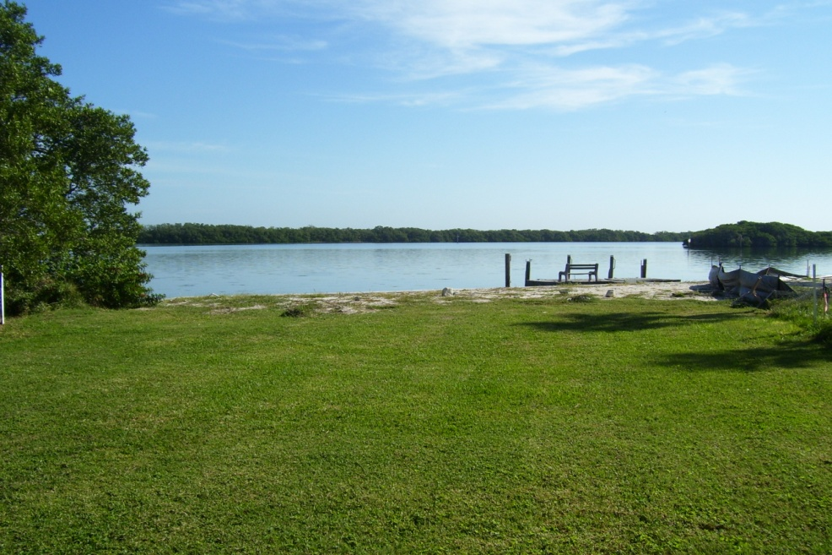

755 Jackson Way

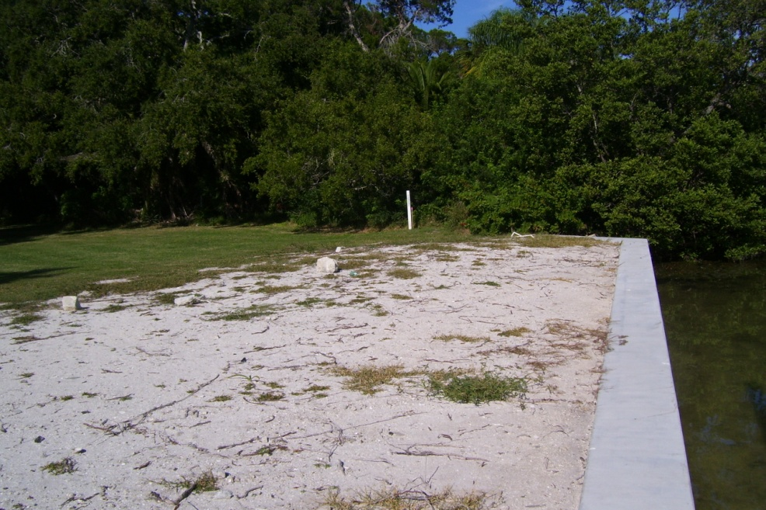

- 505 Lyons Lane
This large parcel (300ft x 2150ft) is part of a mitigation bank agreement between the Town of Longboat Key and the Ritz Carlton Hotel in Sarasota. This coastal hammock was created by the developer of the Ritz Carlton Hotel and deeded to the Town of Longboat Key as part of the development of the downtown hotel. It is heavily vegetated with mostly mangroves. For all practical purposes, this access is unusable for the intended purposes.

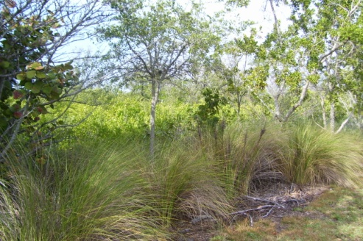

- 821 Binnacle Point Drive
This is a 50ft wide by 40ft strip of land. This parcel is heavily vegetated with mangroves hindering any access. For all practical purposes, this access is unusable for the intended purposes.

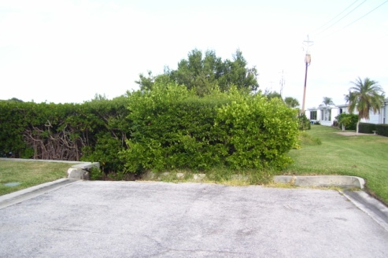

- Durante Park – 5550 Gulf of Mexico Drive
These three accesses are located in various locations within Durante Park providing good access. There is ample vehicle parking at Durante Park.

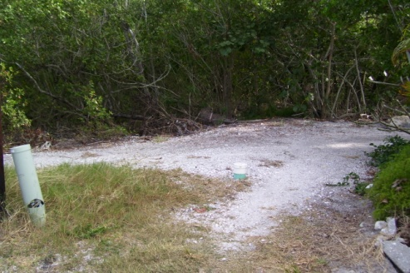

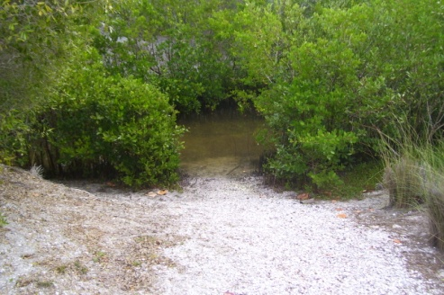

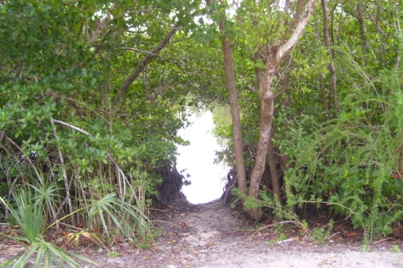

- Bayfront Park – 4052 Gulf of Mexico Drive
This access is located at Bayfront Park and provides excellent access with approximately twenty parking spots. This access has a floating dock.

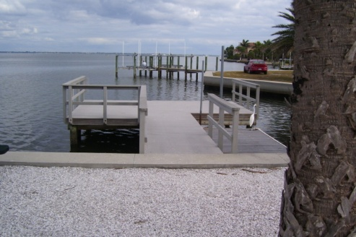

- 3490 Gulf of Mexico Drive
This is a 50ft wide by 160ft strip of land providing excellent access with approximately eight parking spots. This parcel also serves as overflow parking for the beach access directly across Gulf of Mexico Drive.

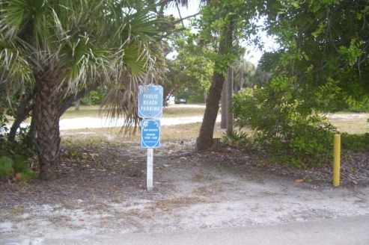

- 3410 Gulf of Mexico Drive
This is a 50ft wide by 270ft strip of land. This parcel is heavily vegetated with mangroves, palms, Brazilian peppers and Australian pines hindering any access. For all practical purposes, this access is unusable for the intended purposes. Removing the invasive trees would not make this anymore accessible. This parcel has a beach access located directly across Gulf of Mexico Drive.

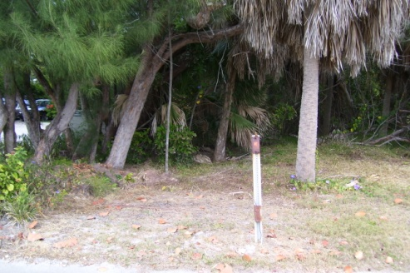

- 3180 Gulf of Mexico Drive
This is a 50ft wide by 350ft strip of land. This parcel is heavily vegetated with mangroves, palms, Brazilian peppers and Australian pines hindering any access. For all practical purposes, this access is unusable for the intended purposes. Removing the invasive trees would not make this anymore accessible.

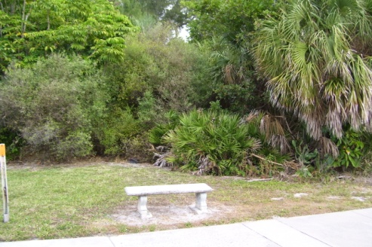

755
Linley Street
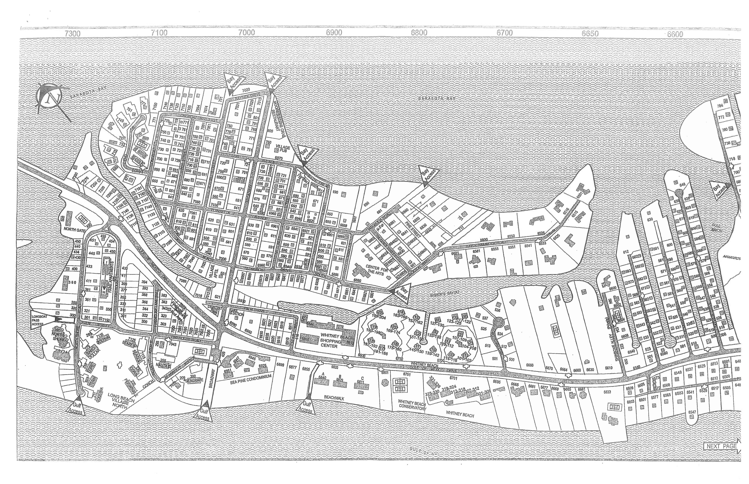
755
Jackson Way
7199 Joy Street
(Pass Access)
700
Cedar Street
899 Broadway Street
800 Russell Street
695
Hibiscus Way
6800 Longboat Drive South
6930 Bayside Drive (8950 Lois Street)
755
Magnolia Road
505
Lyons Lane

821
Binnacle Point Drive

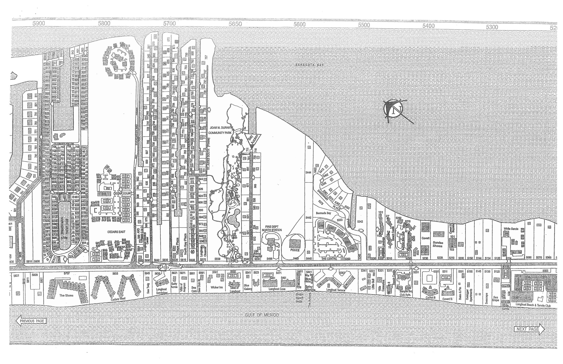
Durante Park
5550 Gulf of Mexico Drive

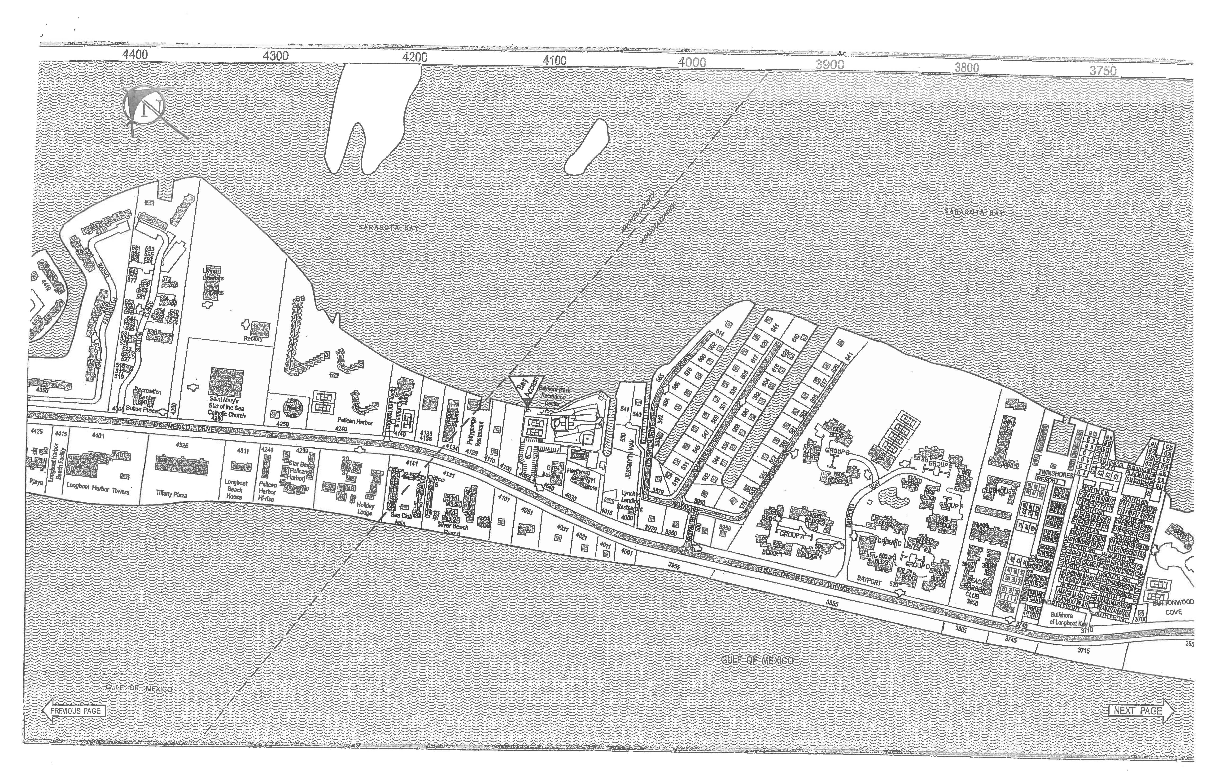
Bayfront Park
4052 Gulf of Mexico Drive

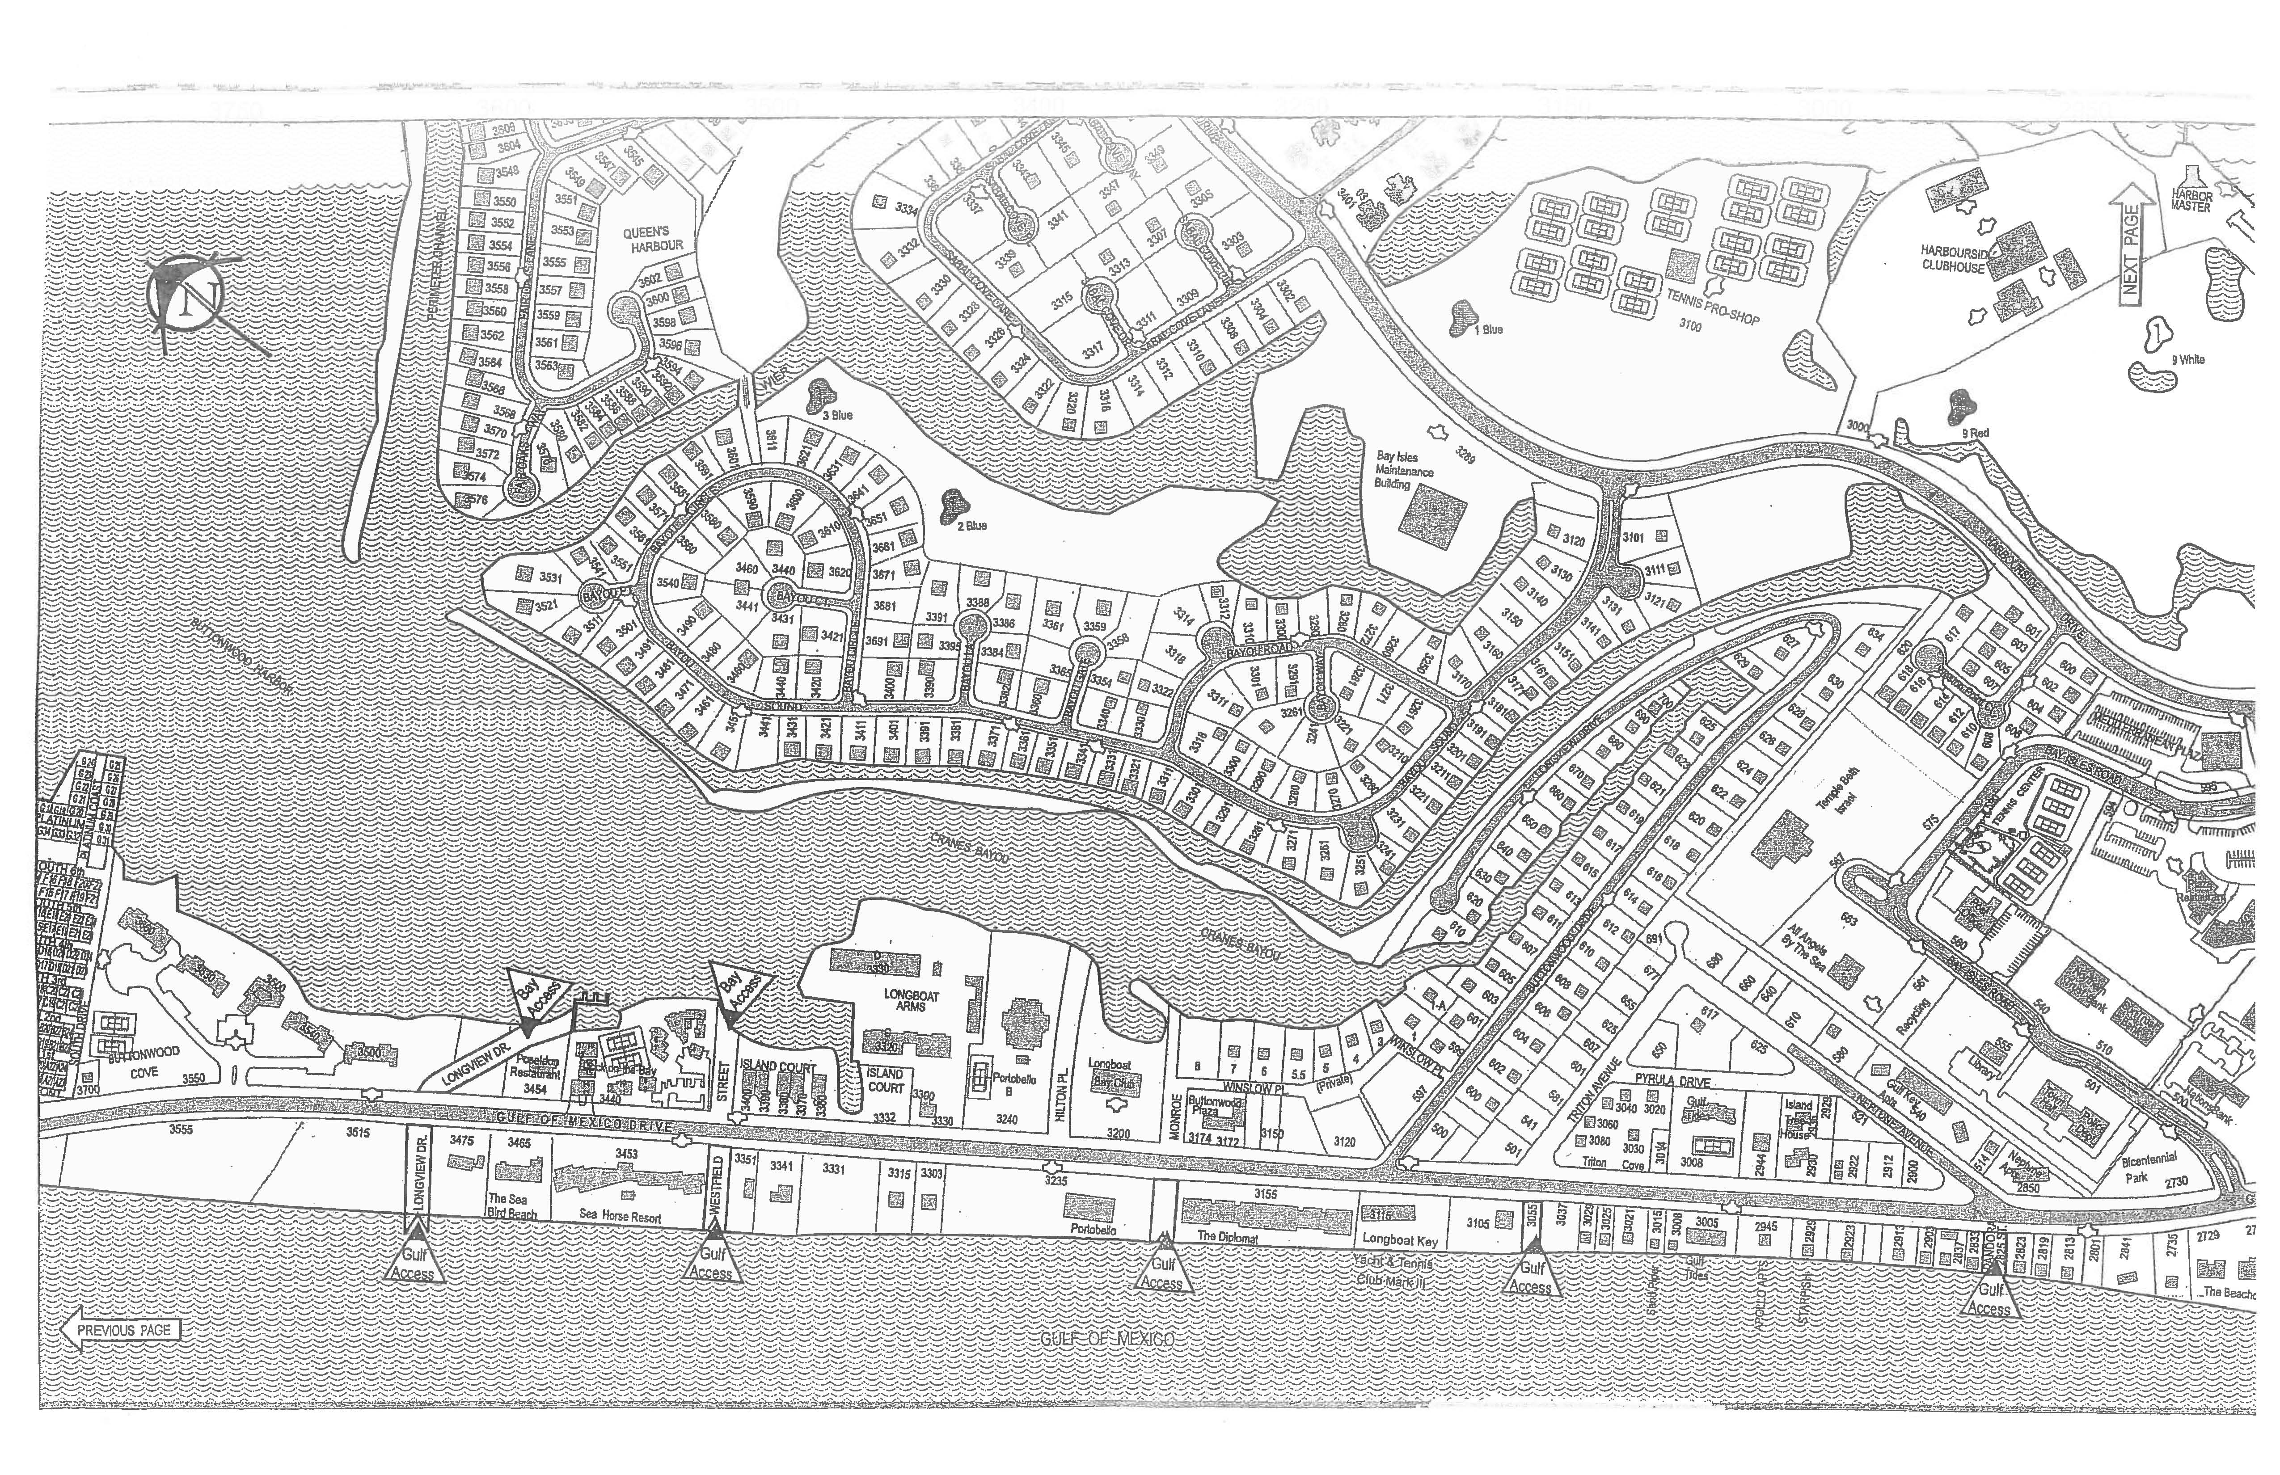
3180
Gulf of Mexico Drive
3355
Gulf of Mexico Drive
3490
Gulf of
Mexico Drive

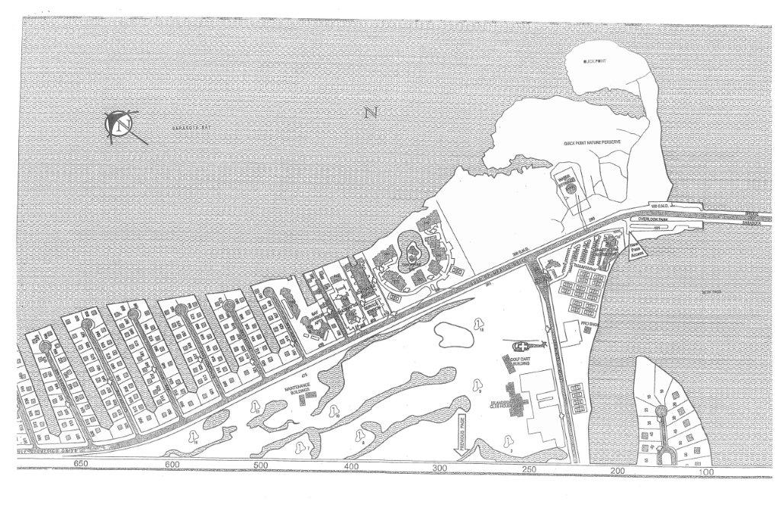
Overlook Park
111 Gulf of Mexico Drive
(Pass Access)
Quick Point
100 Gulf of Mexico Drive
(Pass Access)

