Town of Longboat Key
Village Alleys

The study area is bounded by Longboat Drive N/S to the West, Sarasota Bay to the East, Longboat Court to the North and Jackson Way to the South.

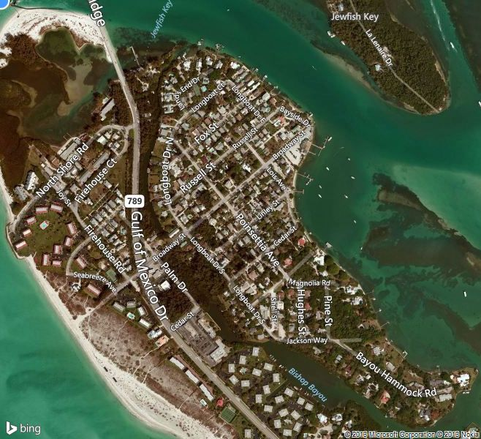

Town of Longboat Key
Village Alleys

- Located between Broadway and Russell Street from Longboat Drive North to Bayside Drive.
This accessible shell alley is platted and approximately scaled at 17.5ft wide by 1,400ft long. It is also utilized by Waste Management for garbage pick-up. In some areas, the width is encroached by vegetation and fences from neighboring properties.

View from Longboat Drive North View from Poinsetta l

View from Longboat Drive North View from Poinsetta looking West
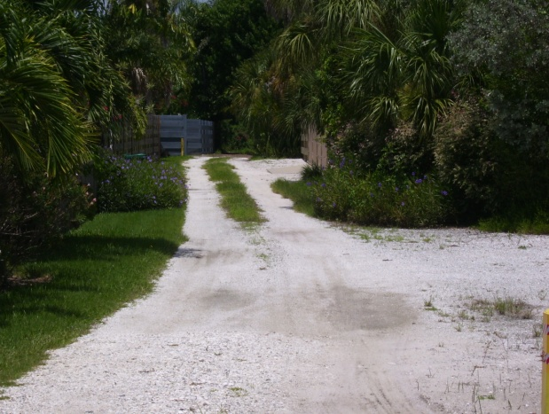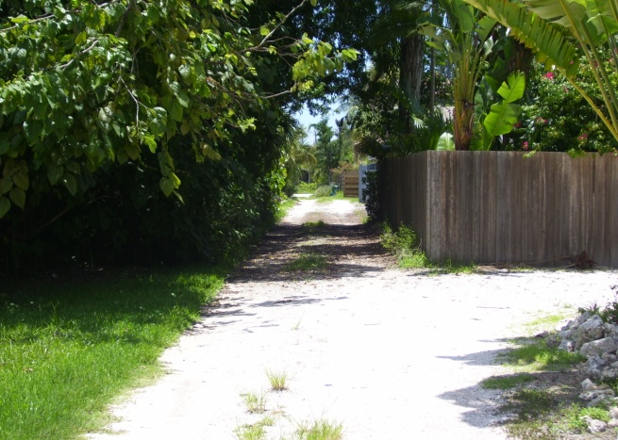

View from Poinsetta looking East View from Lois looking West
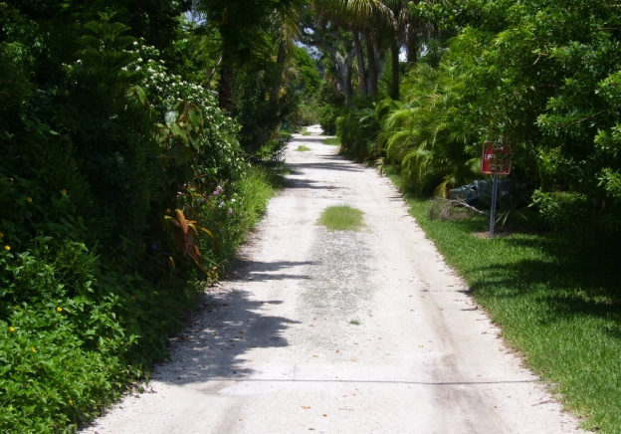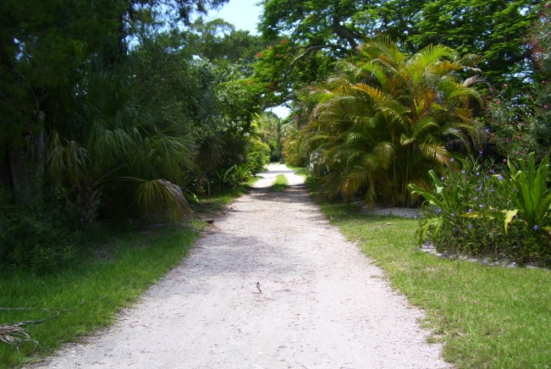

View from Lois looking East View from Bayside looking West
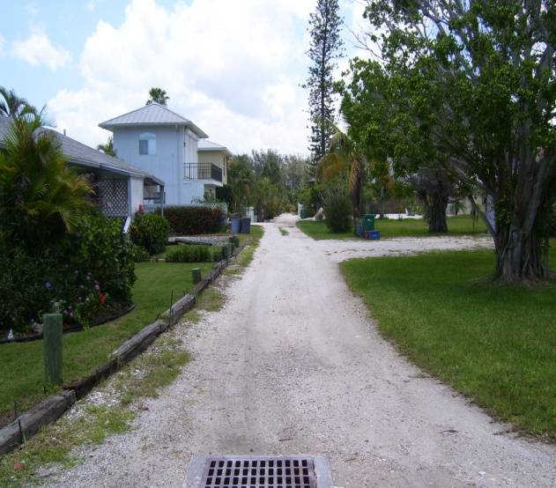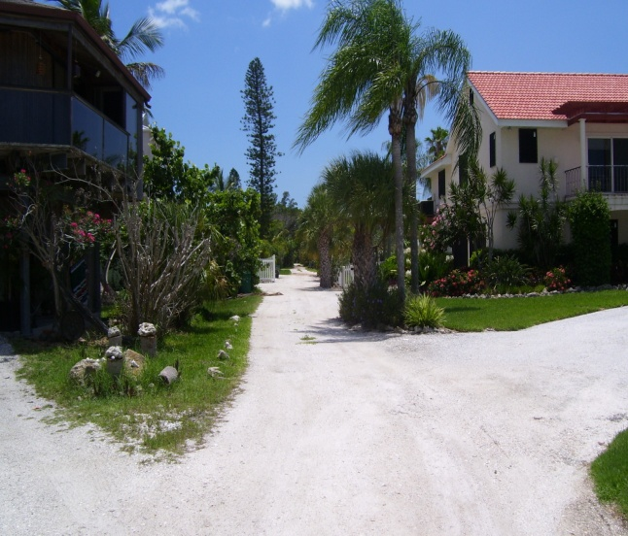

- Located between Broadway and Linley Street from Longboat Drive South to Lois Avenue
This shell alley is platted and approximately scaled at 15ft wide by 870ft long. It is only accessible from Poinsetta Avenue to Lois Avenue (490ft) and West from Poinsetta Avenue (220ft). From Longboat Drive South, vegetation from neighboring properties makes it impossible to access and there are no remnants of an alley. The width is encroached by vegetation in some areas.

View from Longboat Drive South View from Poinsetta looking West
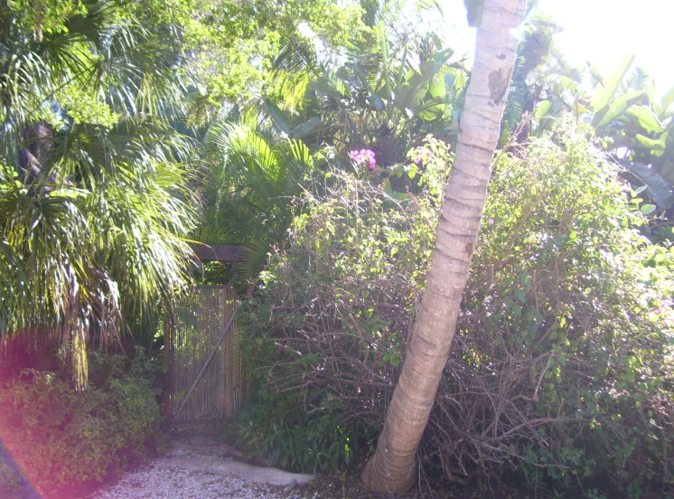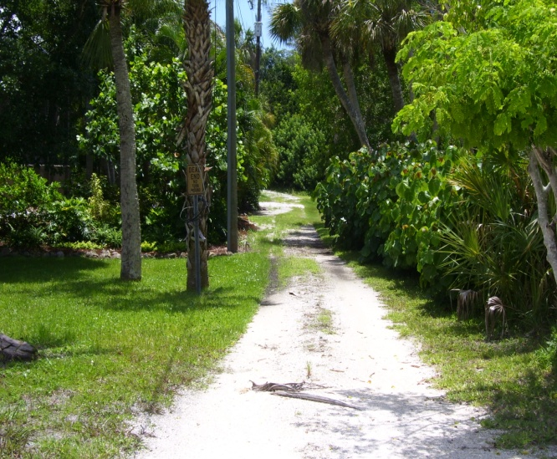

View from Poinsetta looking East View from Lois looking West
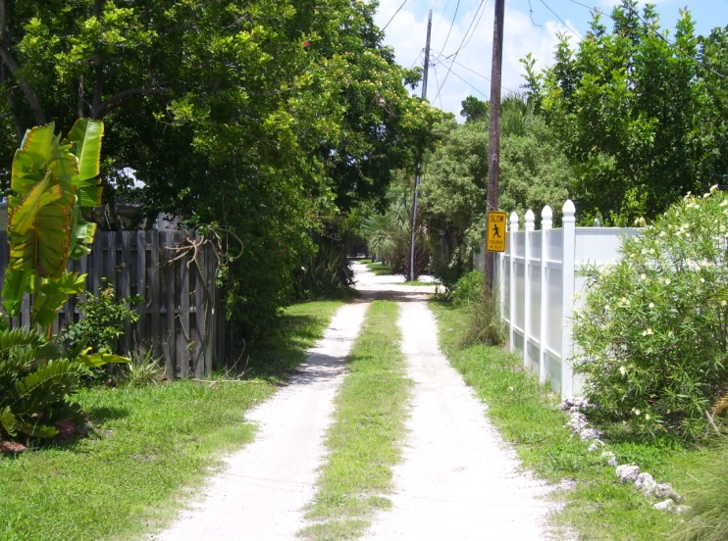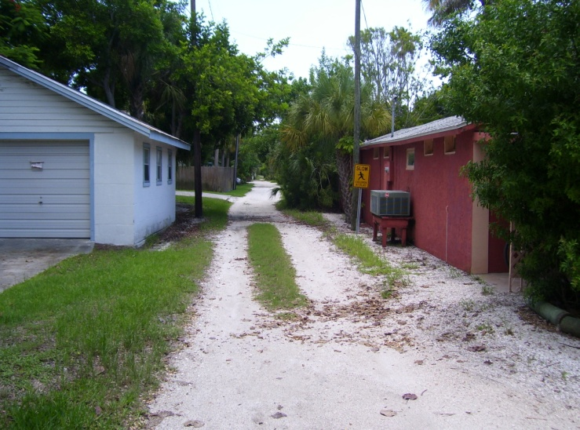

- Located between Linley Street and Cedar Street from Longboat Drive South to Bayside Drive.

This shell alley is platted and approximately scaled at 15ft wide by 720ft long. It is only accessible from Poinsetta Avenue to Bayside Drive (407ft). The portions from Longboat Drive South is approx. 144ft long and from Poinsetta West is approx. 60ft. long that appears to be used for driveway access. The width is encroached by vegetation and fences by neighboring properties.

View from Longboat Drive South View from Poinsetta looking West
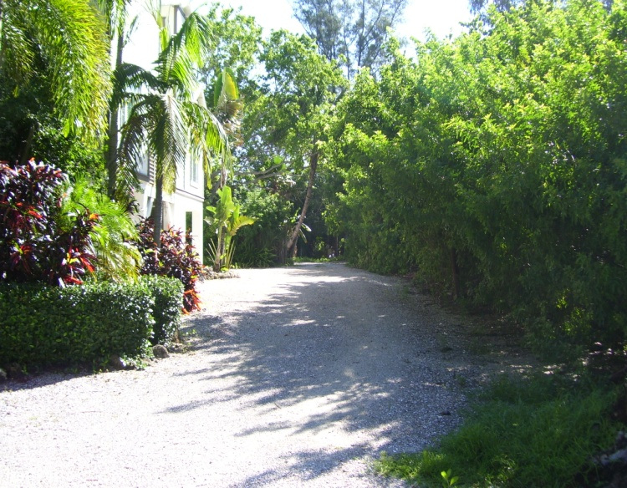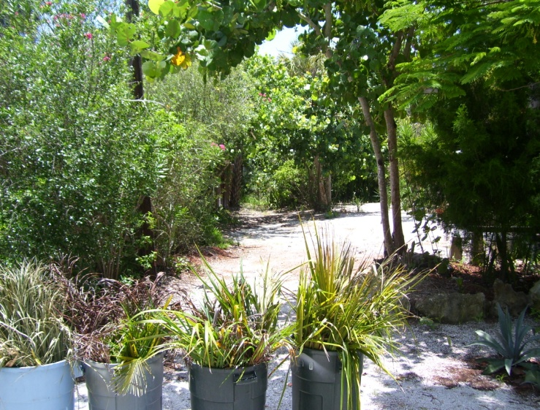

View from Poinsetta looking East View from Bayside looking West
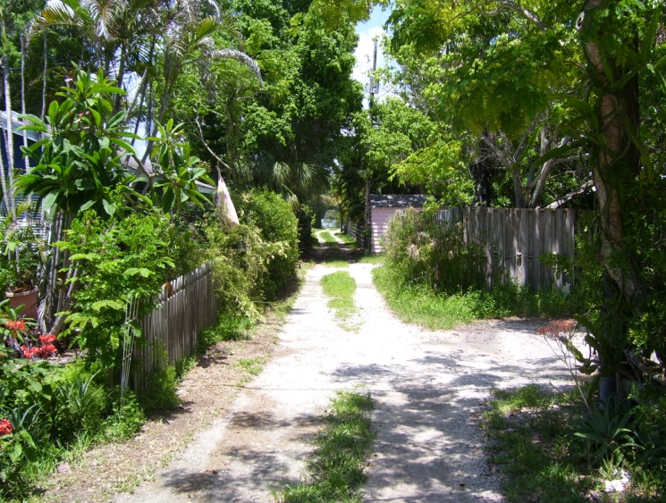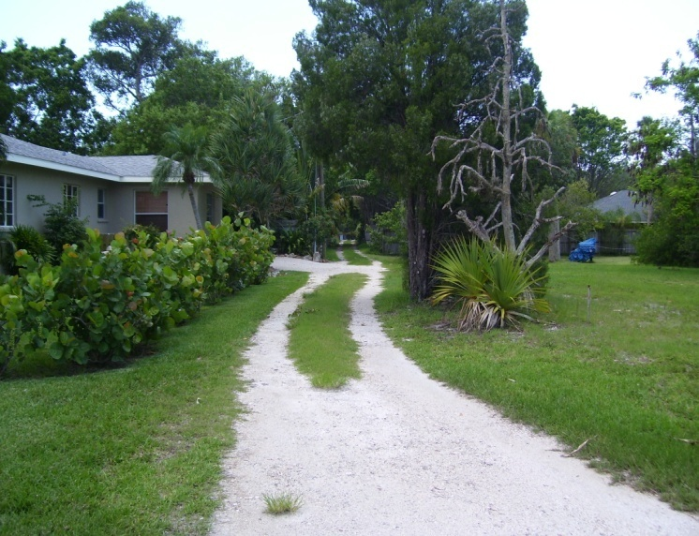

- Located between Cedar Street and Hibiscus Way from Longboat Drive South to Poinsetta Avenue.
This inaccessible alley is platted and approximately scaled at 15ft wide by 530ft long. The portions from Longboat Drive South (151ft.) and Poinsetta looking West (58ft.) appears to be used for driveway parking. The other areas are encroached by vegetation from neighboring properties and show no remnants of an alley ever existing. Ordinance 2000-13 attempted to vacate this alley to the neighboring homeowners with conditions.

View from Longboat Drive South View from Poinsetta looking West
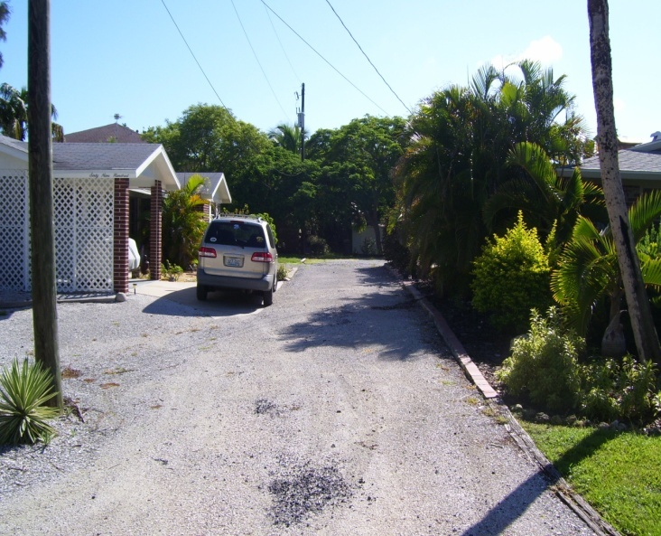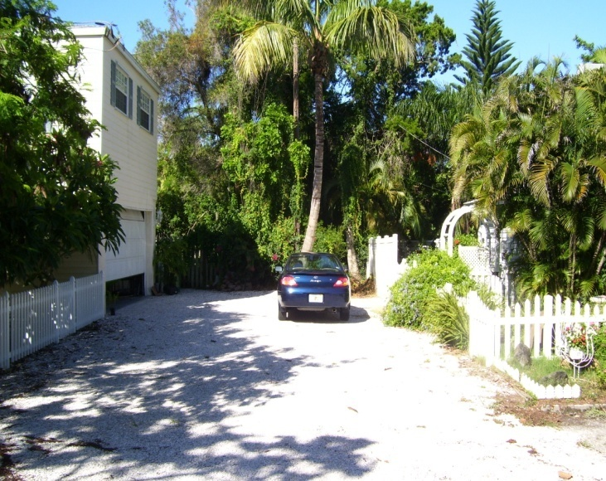

View from Poinsetta looking East
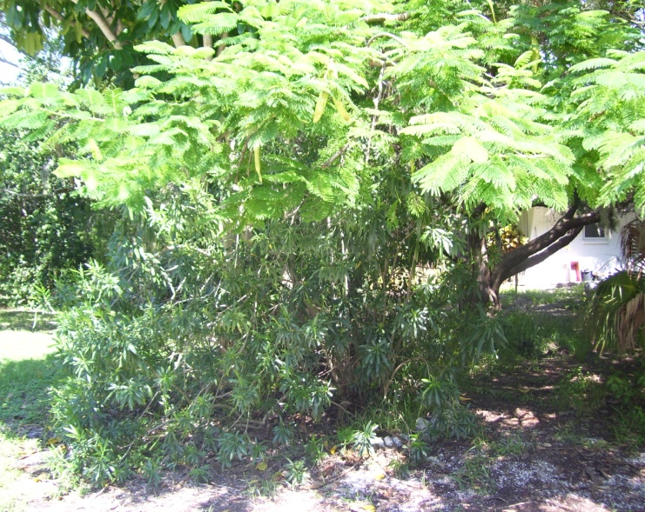

- Located between Hibiscus and Hughes Street from Jackson Way to Magnolia Road.

This alley according to the plat map appears to have been vacated to the surrounding
properties and is approximately scaled at 15ft wide and 500ft long. There are
no remnants of an alley ever existing. Also, a document from the September 8, 1997
Commission Meeting minutes shows this alley vacated.

View from Jackson Way View from Magnolia Road
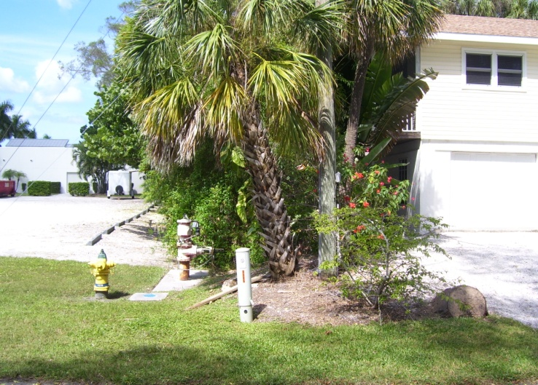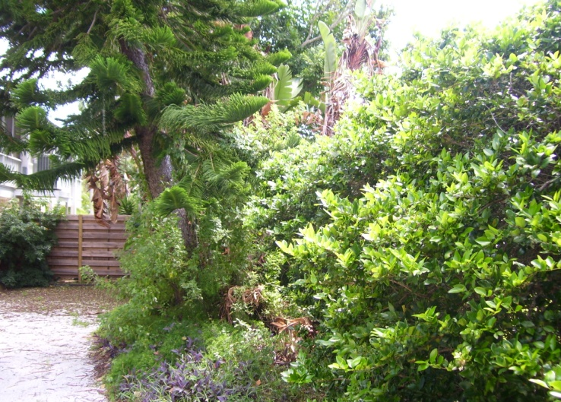

- Located between Hughes Street and Pine Street from Jackson Way to Magnolia Road.
This inaccessible alley is platted and approximately scaled at 15ft wide by 500ft long. This alley is encroached with vegetation from neighboring properties. There are no remnants of an alley ever existing.

View from Jackson Way View from Magnolia looking West
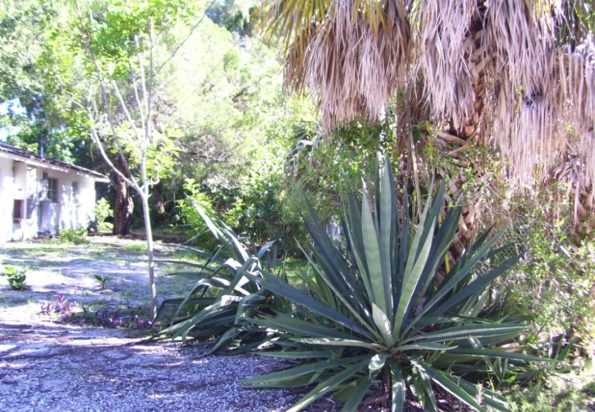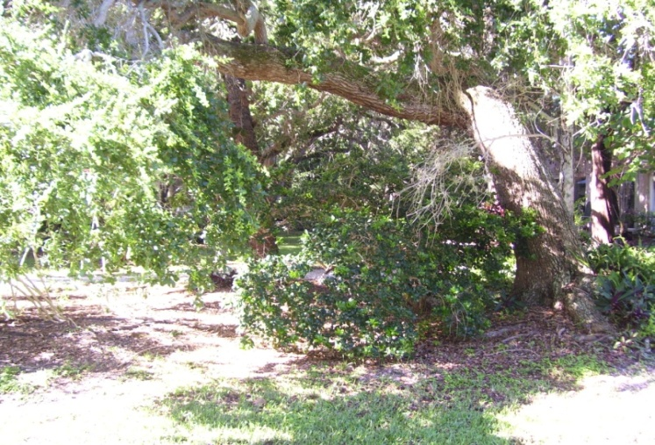

- Located between Pine Street and the bay from Jackson Way to Magnolia Road.

This inaccessible alley is platted and approximately scaled at 15ft wide by 510ft long.the surrounding properties. This alley is encroached by vegetation from neighboring properties.
There are no remnants of an alley ever existing.

View from Jackson Way View from Magnolia Road
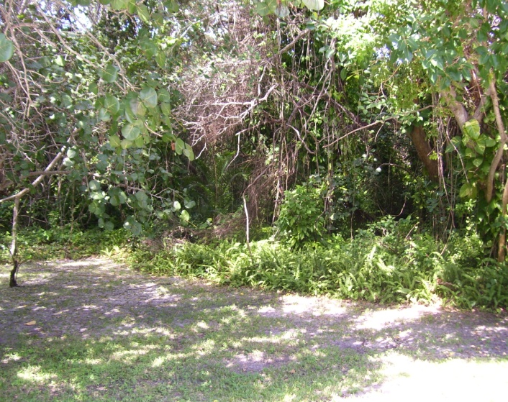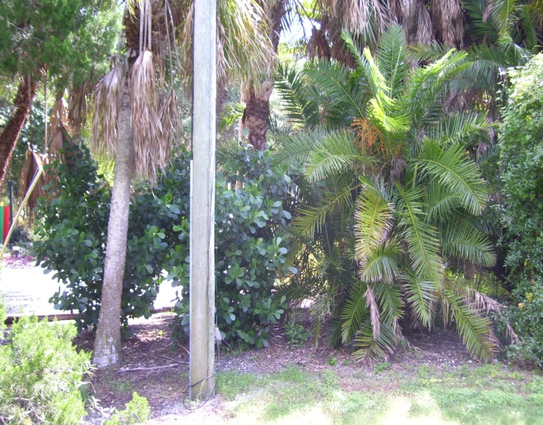

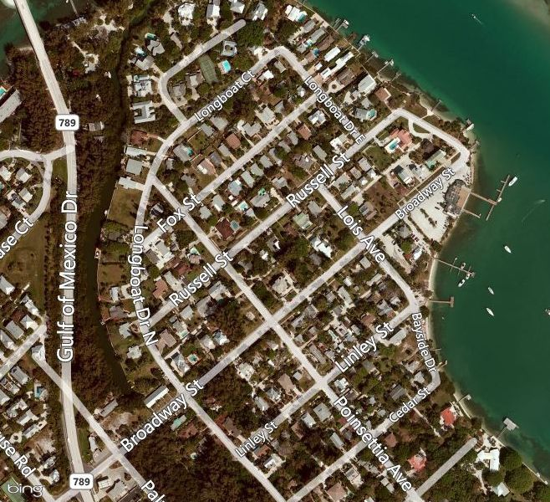
Alley#3
Alley#2
Alley#1

Yellow: represents accessible alleys N
Red: represents inaccessible alleys ↑

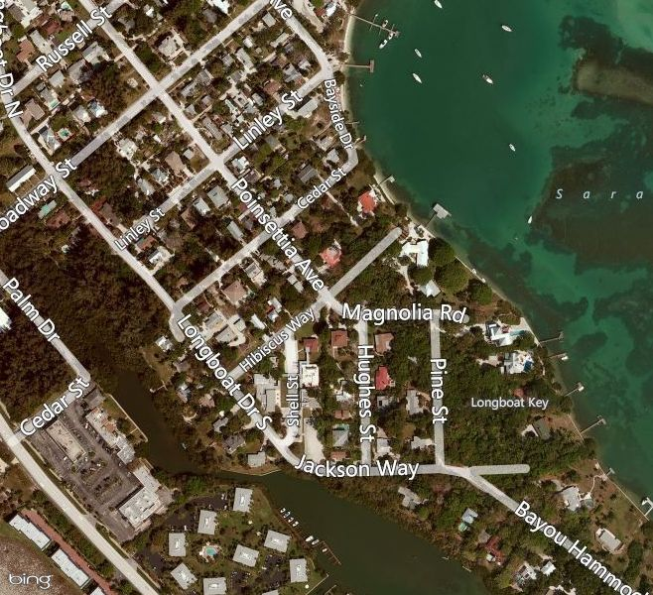
Alley#6
Alley#7
Alley#5
Alley#4

Yellow: represents accessible alleys N
Red: represents inaccessible alleys ↑
Blue: represents vacated alleys

