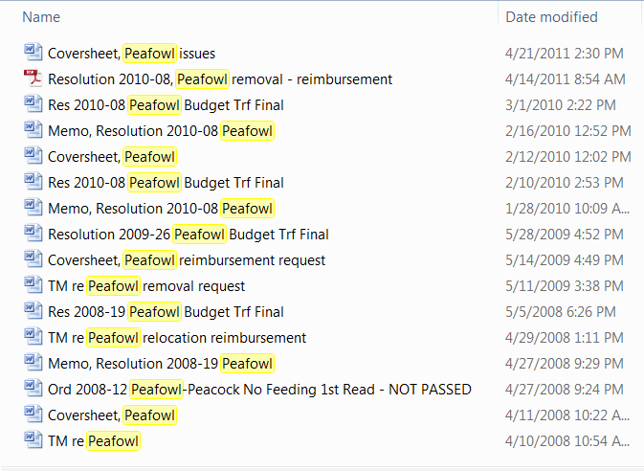
List of query responses for “peafowl” in G\Town_Commission folders are listed above on April 23, 2015. The titles and dates are provided for file reference in answer to the question: “When did the Town Commission last take official action on the issue of peafowl?” April 28, 2011
May 2, 2011 Regular Town Commission Meeting approving minutes of 4-28-11 TCWS;
April 28, 2011 Workshop agenda materials are listed above;
Minutes excerpt: (Town Commission action summation in minutes)
- Commission position to not be in the animal control business
- Monetary contributions made
- Options to provide funding for an additional six months only
- Anticipated removal costs
- Amending the Code to remove the peacock requirements
Michael Drake requested reconsideration on a six-month time limit for removal.
No further recorded action is found in the Commission global files.

