TOWN OF LONGBOAT KEY

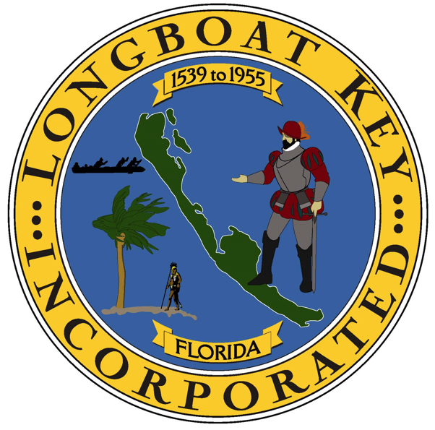

Kelsee Blaska
Employee #1041

Date of Hire: 9/29/25

