HARD COPY PERMIT

ADDRESS, ALTERATION, PARCEL

WORK DONE BY OWNER

RENOVATION

WORK DESCRIPTION INTERIOR ALT - CONNECT TO EXISTING JUNCTION BOX AND ADD GFI RECEPTACLE IN SOFFIT FOR HURRICANE SHUTTER. IN CONNECTION WITH BUILDING PERMIT PB24-0264

MISCELLANEOUS – OWNER, CONTRACTOR,

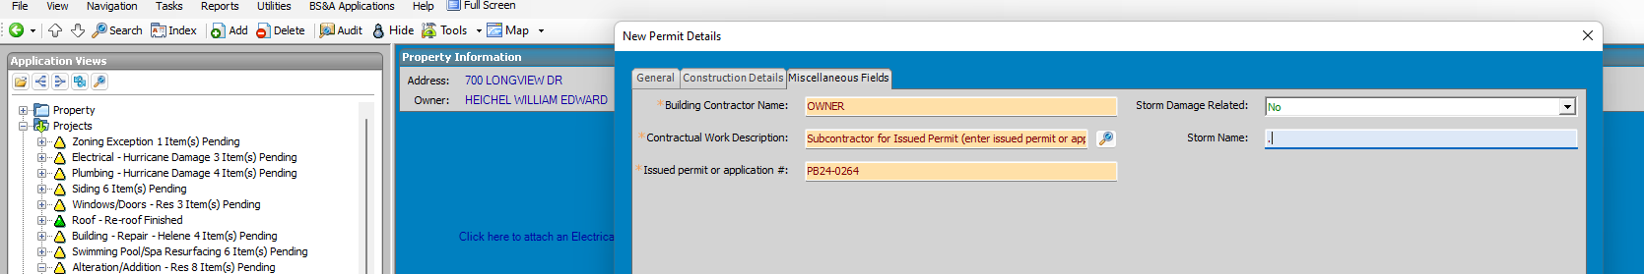

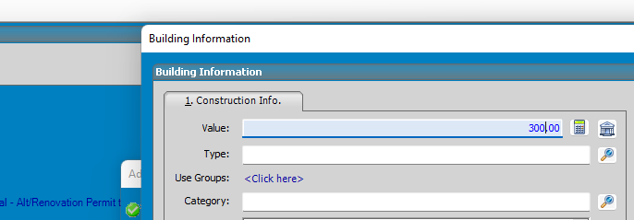

AMOUNT OF CONTRACT

ADD INVOICE – ALTERATION ADDITIONS & REPAIRS……$154

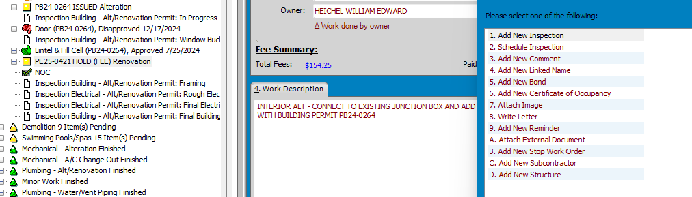

ATTACH EXTERNAL DOC

NAME PERMIT APPLICATION

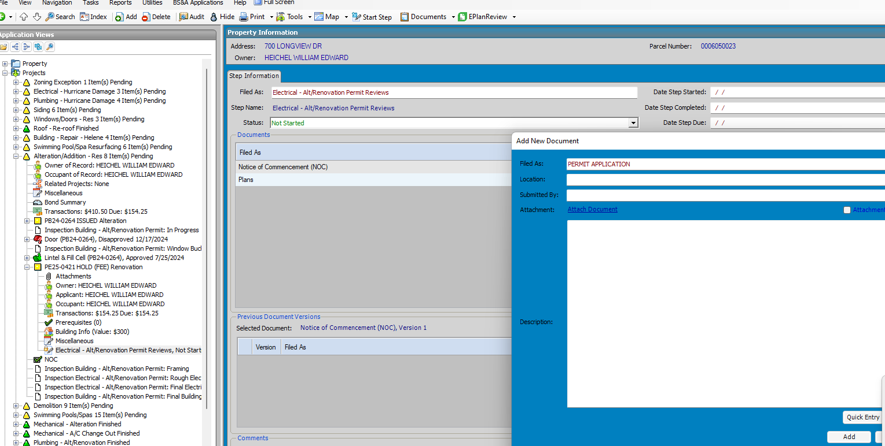

EPLAN

AND CONTINUE