CHANGE OF CONTRACTOR

CTRL F PERMIT#

OK

HIGHLIGHT I.E. PB24-1280 STORM DAMAGE

STIPULATION

03-18-2025 Homeowner requested a removal of themselves as contractor and changed to Lozano Construction LLC approved by building official Patti Fige. See the letters in the file

03-18-2025 Lozano Construction LLC provided an application to take over Permit PB24-1280 approved by Building Official Patti Fige

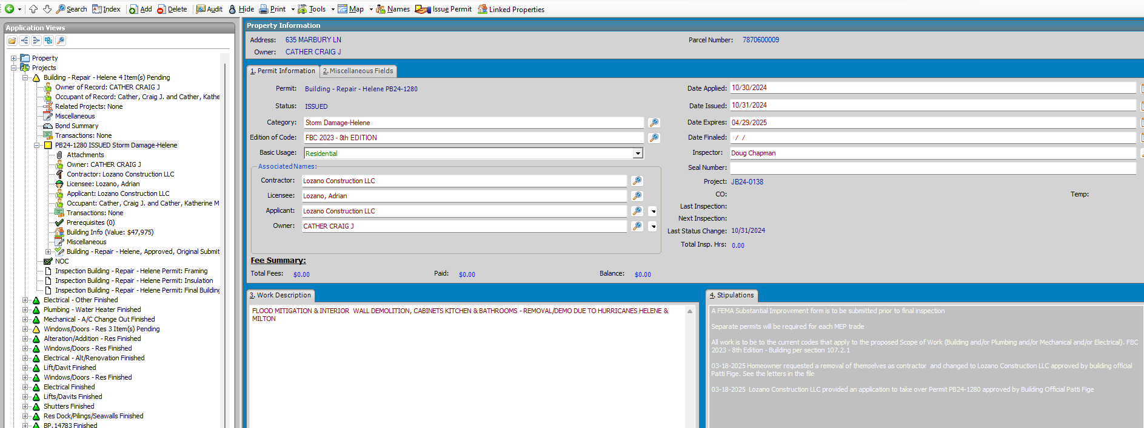

SCAN – CHANGE OF CONTRACT FORM AND ADDTL

ATTACHMENTS - ATTACH EXTERNAL

TRANSACTIONS

ADD INVOICE , REMOVE FEES AUTO

INVOICE - CHANGE OF CONTRACTOR FEE 485

SEND EMAIL - Please find attached the Approved Change of Contractor Documents and Permit Card. There is an $85 fee that needs to be paid. Please contact our office

Contractor/ to email address