* **To pay fees ON OLD SYSTEM – BS&A :** you may pay online. Website: bsaonline.com, change state to FLORIDA, enter municipality “Town of Longboat Key….”, Search by Record (Permit#): PB12-3456

1. Public website for the town of LBK (to pay fees or find permits)

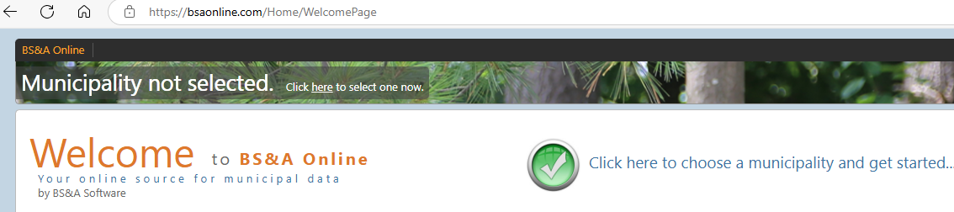

1. CLICK the green check mark in middle of page . Municipal Directory – Change the state from “MICHIGAN” to “FLORIDA”
2. Next to Search - Type/Enter “TOWN OF LONGBOAT KEY”

1. Search:Building department By: Record Number “enter the permit#” i.e. PB24-1234

1. After you enter permit# & To the far right hit [SEARCH]



1. In the middle of page and to the far right (pink/peach box “AMOUNT DUE/PAYNOW”

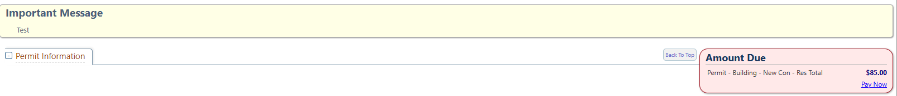

* **To schedule inspections –** Contact Jamie Anderson at phone# 9412518114 and email [janderson@longboatkey.org](mailto:janderson@longboatkey.org)... Please provide permit#, address, date/time of inspection preferred, phone#, email