Long Version
Reid Gerletti was born and raised in Sarasota and has been an artist since he was young. Before high school Reid realized his abilities for drawing and decided to audition for the Booker High School Visual and Performing Arts program. From there began an eight year journey of exploration of art in various mediums from ceramics to painting. Then Reid was accepted into Ringling College of Art and Design where he earned a Bachelors in fine arts in Illustration. As a freelance artist, Reid worked in a variety of roles from muralist to technical illustrator. As a lifelong resident of Sarasota, Reid has worked in graphic design and marketing and sales for a local real estate agency. Currently you can find Reid working on his art at his downtown studio on Main Street in Sarasota. His work has been shown in a variety of galleries and shows in Sarasota. Reid is a nature lover and enjoys spending lots of time outdoors. One of his favorite painting styles is en plein air, working from life in nature, painting landscapes, seascapes and sunsets. Using primarily oil paint, Reid's creative process allows for a natural progression capturing the natural surroundings of the local beaches, parks and waterfront. Reid has also worked in figurative studies, and conceptual painting. His favorites mediums are oil, watercolor, and pen and ink. Reid has also been working with wood and epoxy resin. He's made several different types of tables that are functional yet have an artistic edge to them.. If you are interested in seeing or purchasing Reid's work, or if you'd like to take a class on plein air painting, contact Reid today!
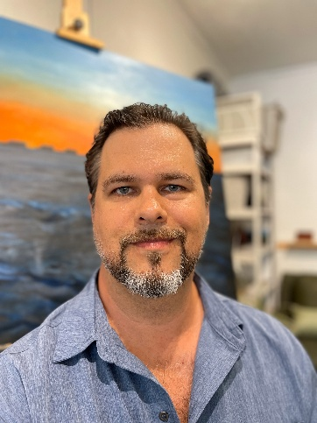
Short Version
Reid Gerletti was born and raised in Sarasota and has been an artist since he was young. Before high school Reid realized his abilities for drawing and decided to audition for the Booker High School Visual and Performing Arts program. From there he began an eight year journey into the exploration and education of art in various mediums from ceramics to painting. Then Reid was accepted into Ringling College of Art and Design where he earned a Bachelors in fine arts in Illustration. As a freelance artist, Reid worked in a variety of roles from muralist to technical illustrator. As a lifelong resident of Sarasota, Reid has worked in graphic design, marketing and sales for a local real estate agency. Currently you can find Reid working on his art at his downtown studio on Main Street in Sarasota where he paints and creates wood and epoxy art and furniture. His work has been shown in a variety of galleries and shows in the area. Contact Reid for more information about his artwork.

Edited Short Version:
Reid Gerletti, a Sarasota native, has been passionate about art since childhood. He discovered his drawing talents before high school and auditioned for the Booker High School Visual and Performing Arts program, which began his eight-year exploration of various art forms, including ceramics and painting. Reid then attended Ringling College of Art and Design, earning a Bachelor’s in Fine Arts in Illustration. As a freelance artist, he worked in diverse roles, from muralist to technical illustrator. Additionally, he has experience in graphic design, marketing, and sales with a local real estate agency. Today, Reid works in his downtown Sarasota studio on Main Street, creating paintings, wood and epoxy art, and furniture. His work has been featured in several galleries and shows throughout the area.

