2024 Annual Report (Public Works)
Hurricane Cleanup
As you are aware, the Town suffered impacts from 3 storms in 2 months. Hurricane Debby brought up 19 inches of rain, then Helene impacted the Key with 8-9 feet of storm surge, and finally Milton brought damaging winds.
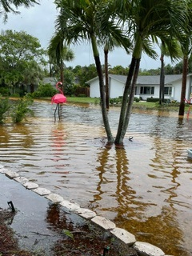
Hurricane Debby made landfall on August 5, 2024, bringing heavy rainfall, strong winds, and significant storm surge. The recorded rainfall reached up to 19 inches over several days, leading to widespread flooding, particularly in low-lying areas such as Gulf of Mexico Drive and several neighborhoods. Throughout the impact of Hurricane Debby, the Longboat Key Utilities Department took decisive action to manage these challenges. Staff remained on high alert and coordinated closely with emergency services to ensure timely communication with residents regarding their safety and the status of essential services. Public Works provided pre-storm sandbag operation all while preparing our facilities and moving all valuable assets out of harm’s way. Through this action the wastewater system remained operational despite the challenges, with 24 of our 47 lift stations experiencing significant saltwater inundation. In addition, all the Public Work’s assets remained operational. All affected stations were restored to operational status as repairs progressed.
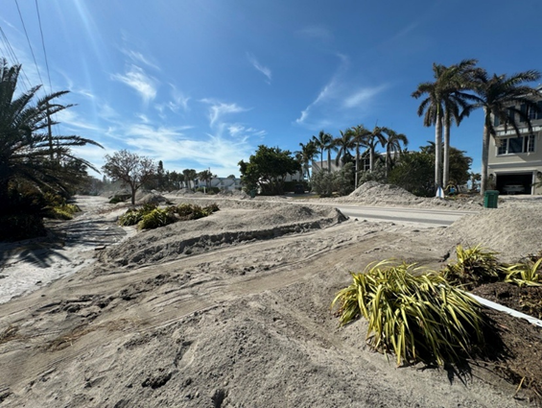
Hurricane Helene hit in late September. Helene compounded the difficulties caused by Debby, resulting in significant damage to key infrastructure, particularly the sewer lift stations, which suffered damage to electrical components. The water distribution system also experienced flooding and equipment issues.
Following Helene, the Longboat Key Utilities Department acted quickly. With the support of partners such as FPL, Bonita Springs Utilities Inc., Blue Septic Tank Service, Sarasota County Utilities, Manatee County Utilities, the Florida Rural Water Association, and the City of Sarasota, we secured the wastewater system and restored fresh water to operational status. This collaboration with regional agencies was vital for achieving full functionality. Public Works Streets, Parks and Facilities staff cleared roads, cleaned facilities, restored drainage facilities, and made our beaches safe. We coordinated damage assessments and initiated the claim process with FEMA.

These storms posed a magnitude of challenges, all of which the Town overcame. As the Town continues through the recovery process, here are a few facts to remember: to date, the Town has collected approximately 40,000 cubic yards of storm debris, cleaned and jetted all of our storm drains, cleaned and raked the beaches twice, reestablished our utility services (multiple times), and reopened all of our parks and beach access points that were safe to do so. Through pre-storm preparation to post storm recovery Public Works has faced and overcome all challenges.

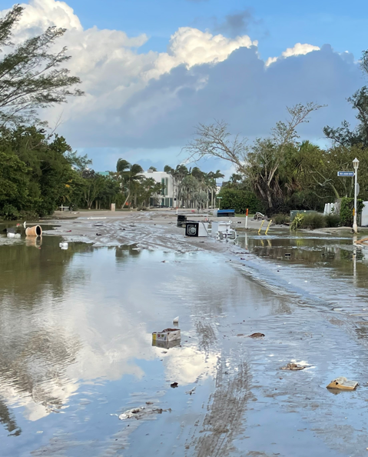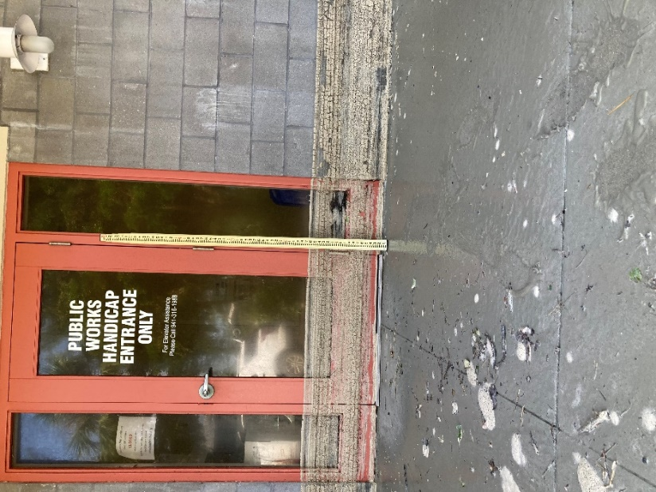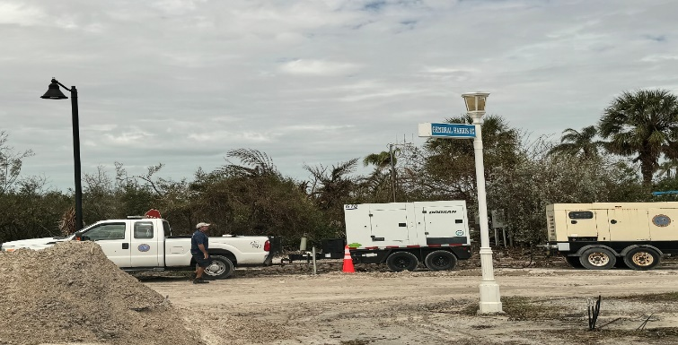

Gulfside Segment Interim Beach Nourishment and Structural Solution
The Gulfside Beach Segment has been identified as an erosional hotspot in the Town’s Beach Management plan, caused by the seawalls and structures on that segment of the beach. The last time it was nourished was in 2021, but due to the erosion caused by these structures the nourishment only lasted a few years, and the depletion was exacerbated by the storm events of the last few years. The Town is in the permitting process to develop a structural solution to “lock” nourished sand in place. But, due to the severity of the erosion, the Town is moving forward with an interim nourishment which started in September 2024 and will conclude in February of 2025. Atlantic and Gulf Dredge and Marine, LLC was awarded the contract for $2,554,968.00 and is proceeding. We are targeting an FDEP grant, in an attempt to get this interim nourishment funded, in its entirety, by the state.
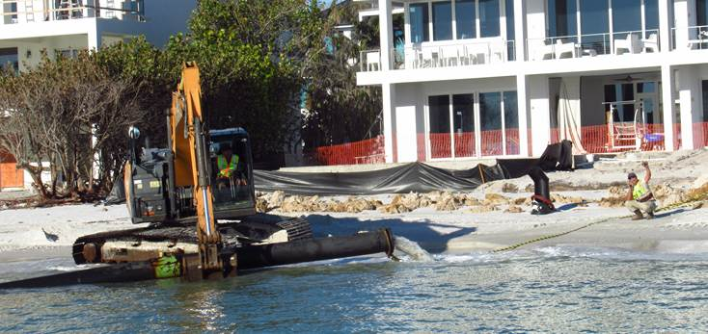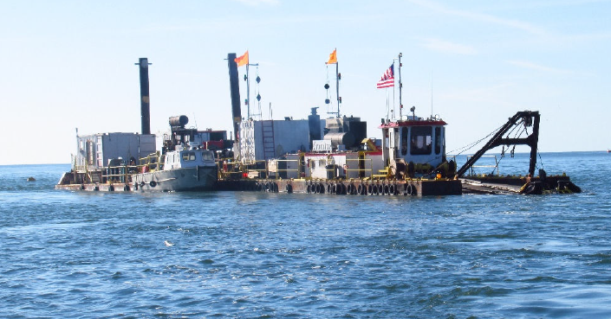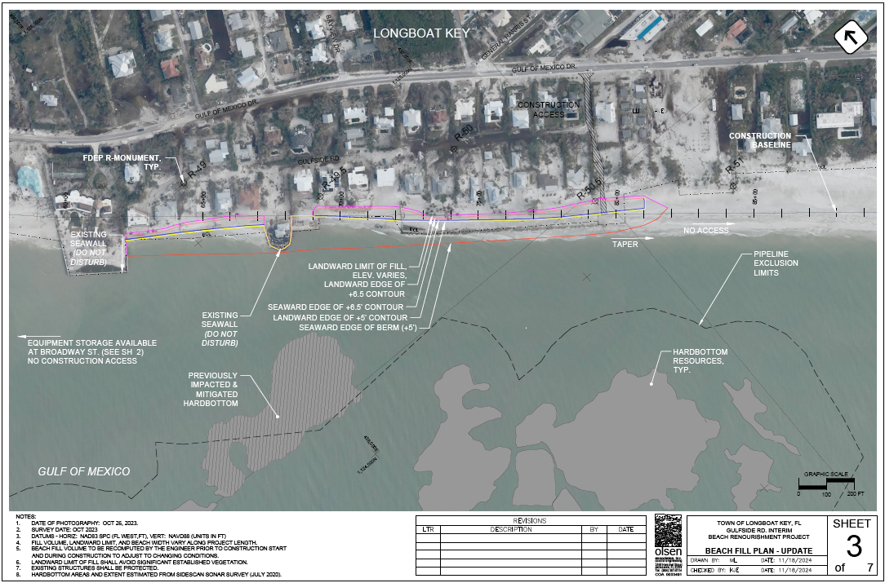

New Pass Terminal Groin Maintenance Project
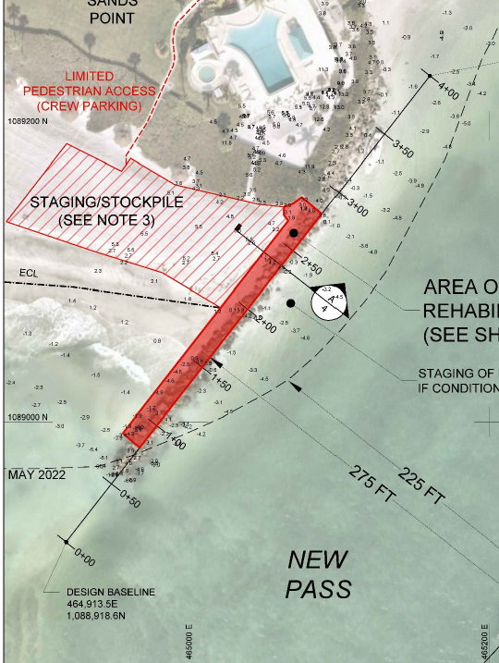
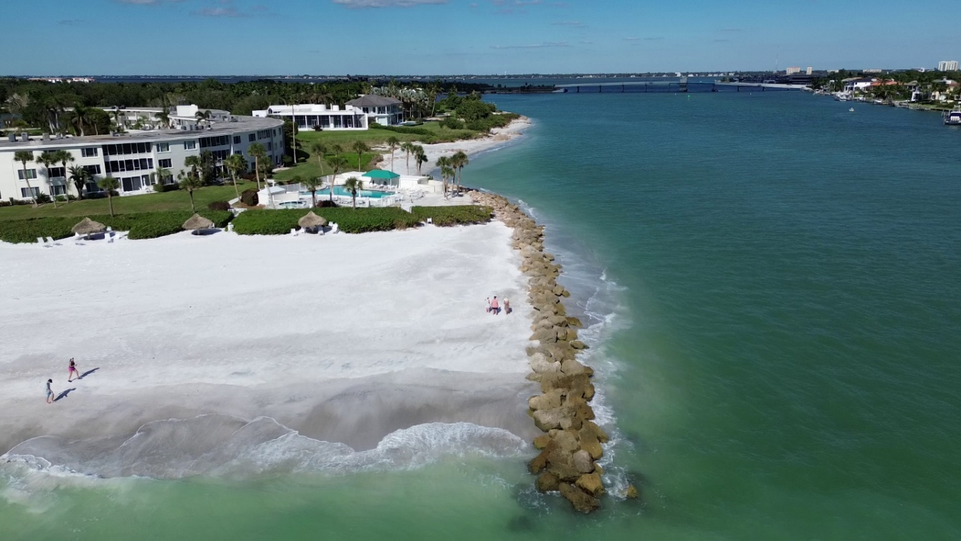
The New Pass terminal groin, last constructed/repaired in 1998, has experienced deflation and differential settlement, as well as rock separation, over the last 24+ years, such that the structure has become excessively permeable. This permeability leads to increased sand transport through and over the structure, contributing to sand losses from the Gulf of Mexico shoreline to the pass. In an attempt to minimize the losses of sand through and over the groin, Longboat Key conducted a successful maintenance project. This project required removing and stockpiling existing rock, adding a geo-fabric wall and adding large armor stones and replacing the existing rocks, in a way to make the groin function as it should. The Contractor, Sea and Shoreline, LLC. Completed the Project under budget, for $471,284.70. They commenced the project in October of 2023 and concluded the project in May of 2024.

Town Hall HMGP Hardening Project
The Town has long awaited the Town Hall Hardening Project that kicked off this year. Construction to replace the roof, install all new windows and exterior glass doors with higher impact rating and insulation levels, and in addition, a new generator enclosure and generator will be furnished. The Town successfully negotiated a grant funding increase and time extension. We secured the services of a Construction Manager, Jon F. Swift Construction, who succeeded in concluding an Engineering review and worked through the permitting process. The construction is scheduled to start in December 2024. The new generator will provide enough power to keep the lights on in both Town Hall and the Planning, Zoning and Building buildings, a massive upgrade to what the existing generator can power. Construction is scheduled to continue through May 2025. The total construction cost is $1,921,652.00 with about 73% being covered by the grant.
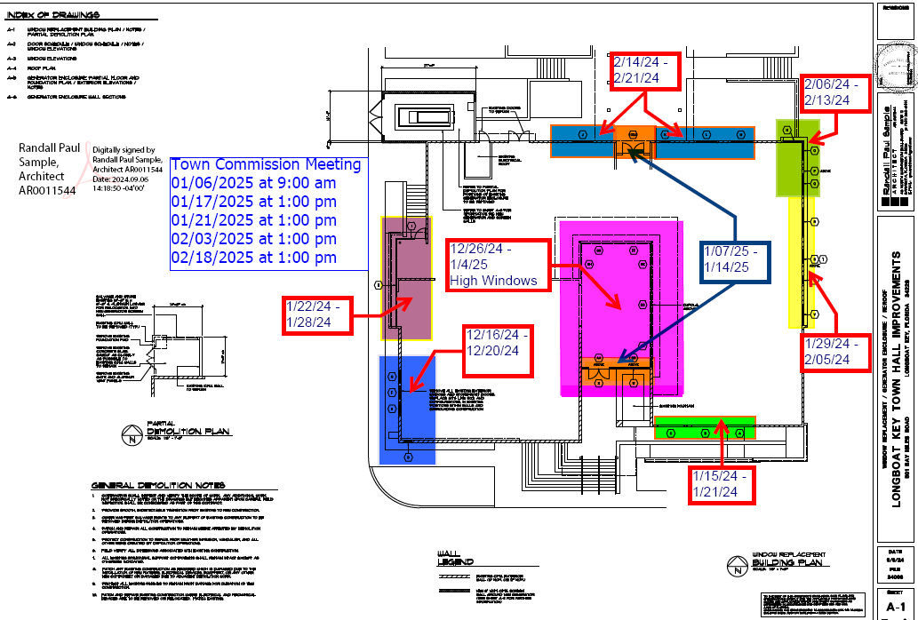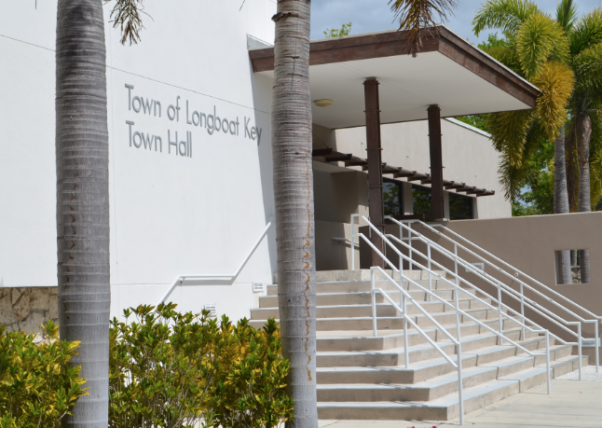

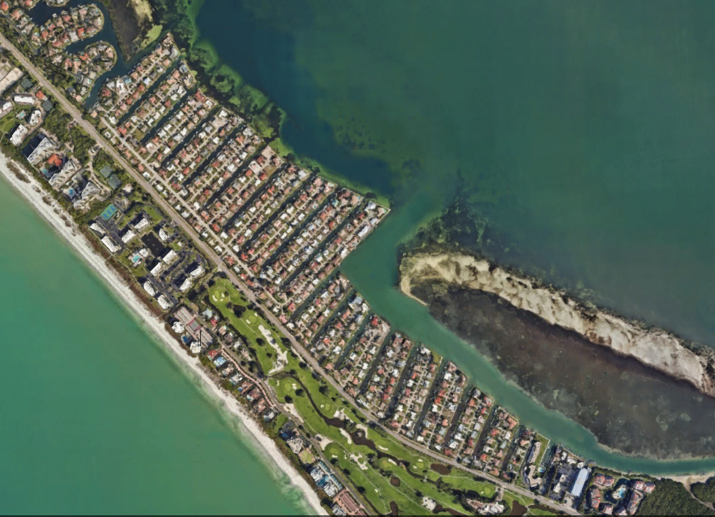
Country Club Shores Asbestos Cement Pipe Replacement Project
Project Phases 1 and 2
Project Phase 3
Project Phase 4
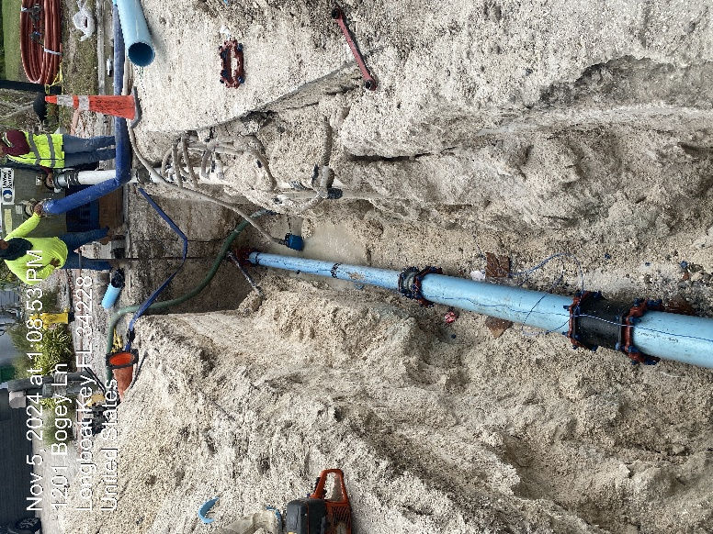
The Country Club Shores subdivision, located at the south end of Longboat Key, consists of five phases, all of which contain asbestos cement watermain pipes that were installed in the late 1960s and early 1970s. Over the years, these pipes have become increasingly fragile compared to other materials, and the use of asbestos cement in water systems is no longer permitted in the industry. Recognizing the urgent need for systematic replacement, the Town has developed a plan to incrementally upgrade the aging water mains throughout the subdivision.
Currently, the first major phases of this project, focusing on replacing the water mains in Country Club Shores Phases 4 and 5, are underway. These areas present the most complex parts of the system and have experienced the highest number of pipe breaks. The design and permitting for this replacement project were conducted by Kimley-Horn and Associates, Inc., while construction work is being carried out by Spectrum Underground, Inc. The estimated cost of the County Club Shores Water Main Replacement Project is $5,536,898.40.
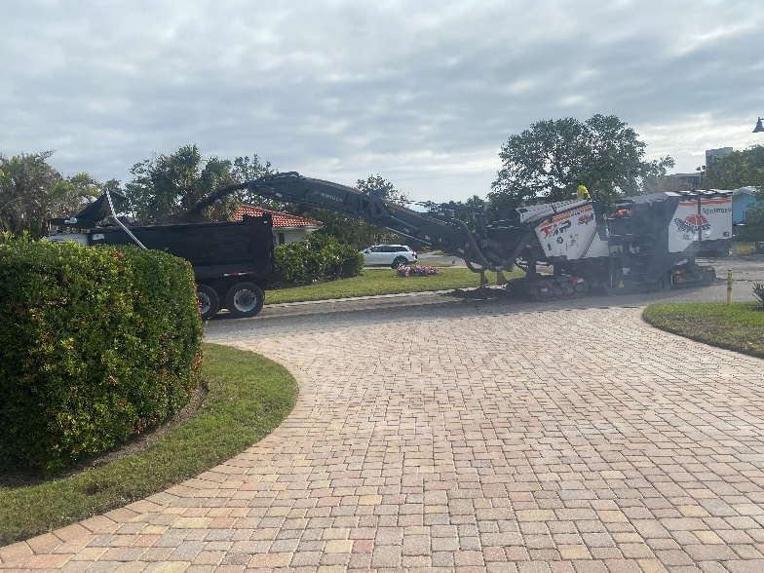
We are pleased to report that the Country Club Shores infrastructure improvement initiative is making significant progress, and we expect completion in spring of 2025. In fact, we are excited to announce that the Country Club Shores Water Infrastructure Replacement Project is not only advancing well but is also ahead of schedule. Our dedicated team has worked diligently to ensure that the upgrades to our water distribution system are completed efficiently and effectively.
By remaining on track and managing resources wisely, we have been able to address urgent needs and enhance our infrastructure sooner than anticipated. This proactive approach means that Longboat Key residents will soon experience the benefits of improved water management, greater reliability, and an enhanced quality of life even sooner than expected.
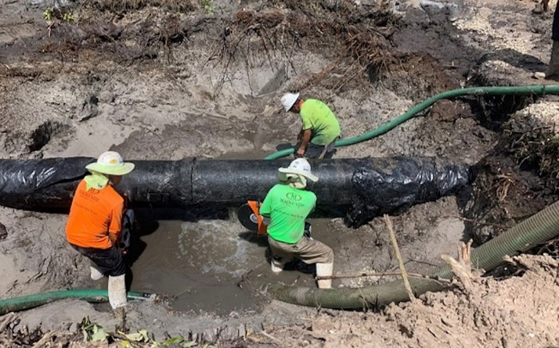
Subaqueous Wastewater Force Main Pipeline
The Town of Longboat Key depends on a 20-inch diameter ductile iron force main pipeline that transports domestic wastewater from the island to the Manatee County wastewater treatment facility, having provided reliable service since 1975. In response to the need for a safe and dependable system, the Town began designing a new redundant pipeline under Sarasota Bay. Following the discovery and repair of a leak in June 2020, the Town accelerated its plans to replace and rehabilitate parts of the aging infrastructure. Recently, a 1.2-mile section of the mainland pipeline was rehabilitated using slip lining with high-density polyethylene pipe to enhance its reliability. As of 2024, the preliminary design for the new force main has been finalized, and all necessary permits have been secured. The design and permitting for the subaqueous project are being conducted by Carollo Engineering and (ESA) Environmental Science Associates. The Town has proposed a $33 million budget for fiscal year 2025 to complete the project, with Garney Construction appointed as the Construction Manager at Risk. To support this essential initiative, the Town is also seeking State Revolving Fund financing, demonstrating its commitment to enhancing wastewater management through proactive planning and upgrades.

Water Meter Upgrade
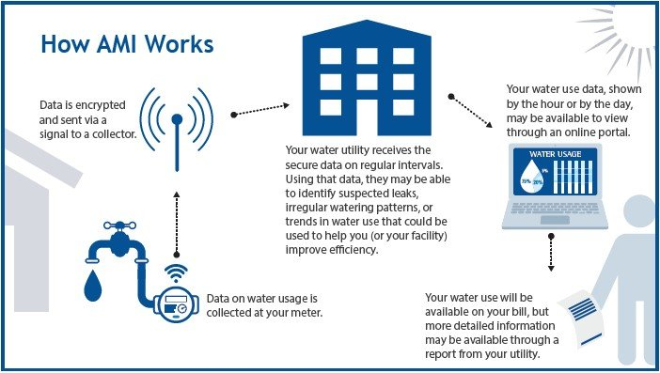

In 2024, the Town of Longboat Key collaborated with Johnson Controls, Inc. (JCI) on a water meter replacement project aimed at enhancing its water meter infrastructure through the implementation of an Advanced Metering Infrastructure (AMI) System. This project involves the removal of existing water meter components and the installation of new Neptune ProCoder encoder registers and ultrasonic water meters, encompassing improvements for over 3,000 water meters. The adopted Utility Fund’s Five-Year Capital Plan (FY2025- FY2029) included a Meter Replacement Project estimated at $2.6 million over five years. Even this amount was anticipated to increase in coming budget adoption years due to additional inflation related to meter materials and increasing cost of labor to install. Working with JCI, the Town proposes an accelerated approach by moving up this project to FY2025 at a cost of $2,016,000. With implementation of the Advanced Metering Infrastructure (AMI) System, customers will have the ability to view their water usage directly on their smartphones through a dedicated mobile app. This app will provide real-time data, allowing residents to monitor their water consumption, track usage patterns, and receive alerts for unusual spikes in usage that may indicate leaks. Users can access detailed reports and statistics, enabling them to make informed decisions about water conservation. Furthermore, the app will offer a user-friendly interface, making it easy for customers to understand their water usage information and manage their consumption effectively.

Pavement Resurfacing Program
The Town re-engaged its pavement resurfacing program and is prioritizing roads and intersections each year to complete. This past year, the Town completed a variety of areas, including the intersections and roads in Longboat Village south. Gator Grading and Paving finished the project for $203,991.65. The Town is obtaining pricing for the next batch of resurfacing and repair areas for 2025.
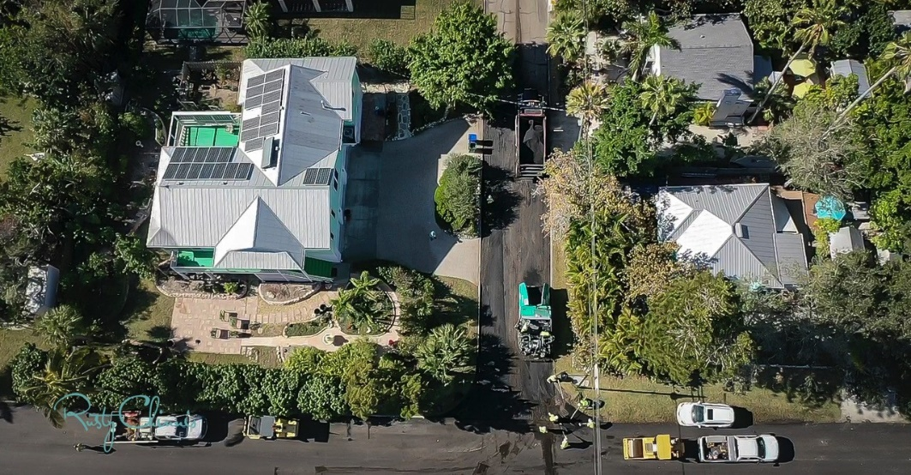

Resiliency Projects

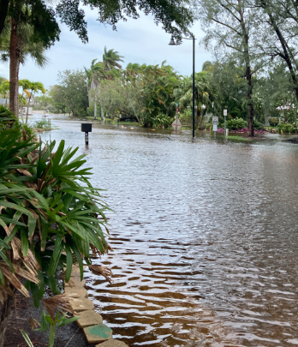
The Town has applied for many grant opportunities to assist in making very low-lying neighborhoods on the Key more resilient to everyday flooding. Areas include the Village, Buttonwood and Sleepy Lagoon. The Town has secured a federal grant for the design of Norton Street (Sleepy Lagoon) and the design and permitting is due to be completed in January 2025. We have received the Notice of Award for Construction Funds, and the funds should be available once the design/permitting effort is completed and closed. The Town has requested Letters of Interest from engineering consulting firms for the design and permitting of the remainder of the phases in Sleepy Lagoon. The Town also received the Notice of Award for the design and permitting for the first 3 resiliency projects in the Buttonwood neighborhood. We are currently working through the procurement process to select a design professional to accomplish that mission. All other design projects for Buttonwood and the Village are pending available funds. We also installed six tidal control valves and replaced two stormwater outfall pipes.

Canal Navigation Maintenance Program
Town staff hired a new consultant team, First Line Coastal, LLC with the support of Willdan Financial Services, to bring a new perspective and additional experience to the development of the Town Wide Canal Navigation Maintenance Program. With this new perspective, staff and the team briefed a new approach to the Canal Program. The approach included the development of new programmatic tools, conducting a conditional survey, and conducting an assessment that ultimately led to over 50% initial program cost savings from the previous estimate. In addition, they identified a potential use of the dredge material that could reduce the cost of the program and benefit the Subaqueous Force Main project. Staff and the consultant team will utilize this information to develop funding strategies, both taxation and assessment, and bring them to the Commission for initial consideration. Ultimately, we will be communicating these options to the citizens, as part of a public outreach campaign in the spring of 2025. This will provide the Town with the tools to potentially maintain another of our quality-of-life assets.
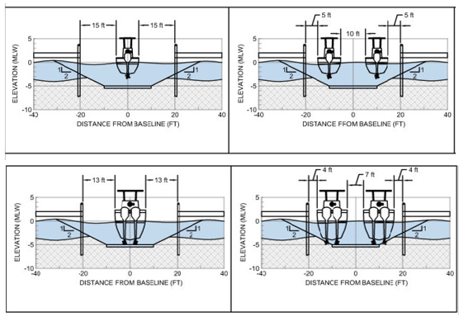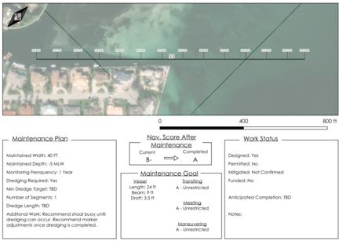

Bayfront Dog Park Artifcial Turf/ Dog Park Solar Lighting
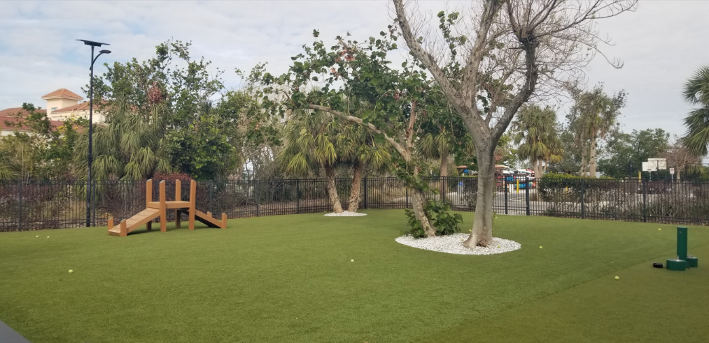
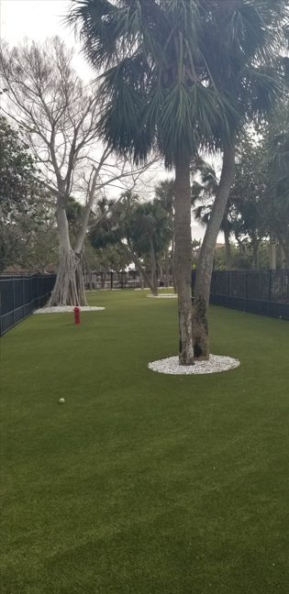
The Town completed installation of K-9 artificial turf to the rest of the large dog park and the entire small dog park. It not only makes the dog park almost maintenance free, but it’s much cleaner for the dogs and their owners. Due to the generous donations collected by the Longboat Key Foundation, solar lighting was installed as well. This allows one of the most popular amenities in the park to be enjoyed during the evening hours. Forever Lawn installed the artificial turf in May/June 2024 at a cost of $175,000.00. The Dog Park lighting was purchased from Fonroche Lighting America and installed by Florida Lighting Maintenance in November 2024. The total project cost was $16,109.00.

Durante Park Boardwalks
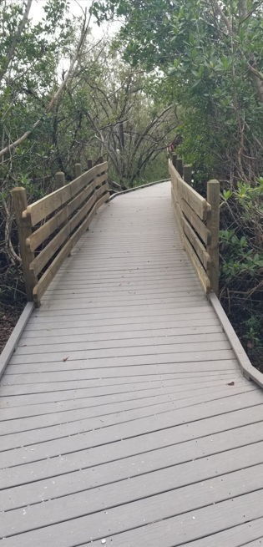
The Town completed the replacement of the remaining wooden boardwalks in Durante Park with composite decking. The composite material is much more durable and created uniformity with all the boardwalks throughout the entire park. This will allow residents/visitors to have a smoother and safer stroll through this beautiful park. The boardwalks sustained significant damage during Hurricane Helene, and the Town has been working to rebuilt and reset them through storm damage insurance claims and through FEMA reimbursement.

Tennis Center/Town Center Green Event Management
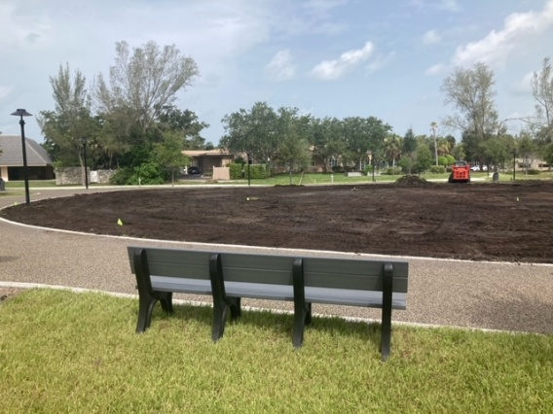
The Town decided to move these two areas under the Public Works umbrella. This move will hopefully streamline operations and create continuity for using Town facilities. The Town also entered into an agreement with the Resort at Longboat Key, who generously offered to help replace and then maintain the sod at the Town Center Green.

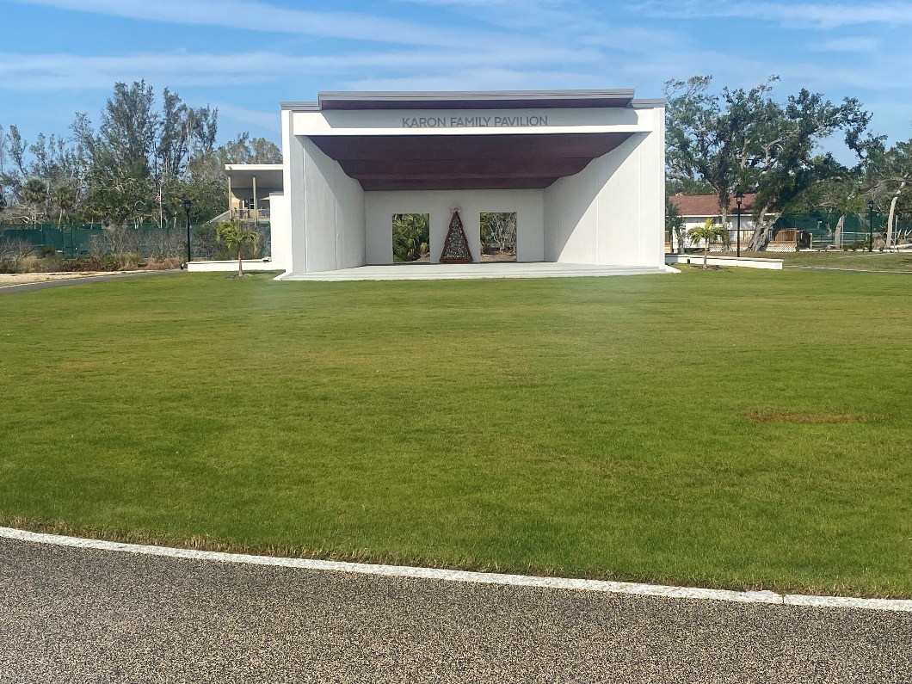

New Roof for Fire Station 91
After leaks were discovered in the Fire Station 91 roof, the Town was able to secure a contractor, Blue Vision Roofing, LLC., and do a full re-roof, and replace all fascia, flashing, valleys, and vents. Blue Vision completed the project in August of 2024, for $192,500.00.
