Where does the money come from?
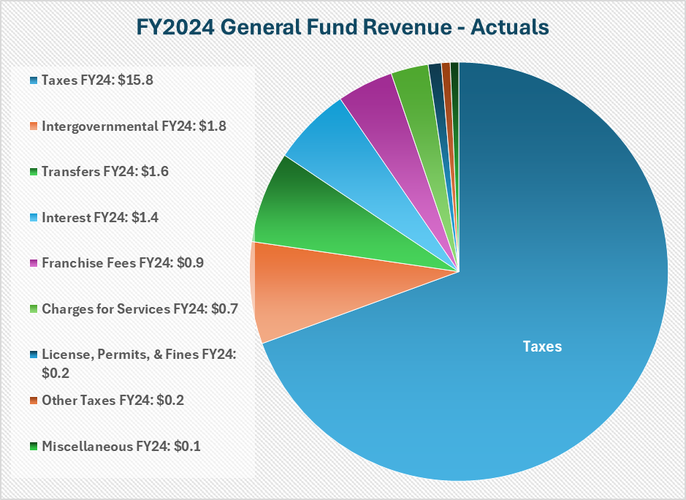
The Town of Longboat Key collected just over $22.8 million in revenue in its General Fund in FY2024 which exceeded budget estimates by $1.7 million. This was in large part due to the Town collecting $940,000 more in interest than budgeted, from the continuation of elevated Federal Funds interest rates. Property taxes make up 69% of all revenues at $15.8 million. Other revenues include State sales tax, communication services taxes, franchise fees (electric, natural gas, solid waste), ambulance billing fees and interest income. The Town’s total revenue came in at 107.95% of the Budget for FY2024.

What does the money pay for?
The largest portion of expenditures in the General Fund is devoted to keeping residents safe. Police, Fire and Ambulance makes up 63% of the operating budget. Other general government services – like Town Administration, Legal, I.T., Purchasing, Human Resources, Finance, Planning & zoning – make up 27% of the General Fund budget. Public Works Administration, Streets and Facilities, accounts for 8% and Parks and Recreation makes up 2% of the budget. The Total Operating Budget Expenditures came to $19.9 million for FY2024. In addition, the Town transferred $5.35 million to Capital Project Funds targeting strategic initiatives. The Town total spending came in at 97.3% of the Total Budget for FY2024.
FY2024 General Fund Expenditures - Actuals

63% 27% 8% 2%
Public Safety $12.6 million
Public Safety General Government Public Works, Parks & Recreation
Streets & Facilities
Public Works, Streets & Facilities $1.6 million
Transfer to Capital Improvements $5.4 million
Parks & Recreation $0.3 million
General Government $5.4 million

