
Business Tax Receipts
The Town Clerk’s Team is responsible for issuing Business Tax Receipts (BTRs), which are required annually for businesses operating within the Town, including residential rentals. BTRs must be renewed by October 1st each year, with the renewal process starting in July to allow ample time for completion. In 2024, the Clerk’s office issued or renewed a total of 2,201 BTRs.
Residential Rental Registry Program
In 2023, the Town Commission adopted Chapter 115, the Residential Rental Registry Program, to the Town Code. The Clerk’s Team handles the administrative tasks of receiving and processing Rental Registration Certificates, issuing a total of 396 registrations in 2024.
ORDINANCE NO. 2022-13
AN ORDINANCE OF THE TOWN OF LONGBOAT KEY, FLORIDA, AMENDING TITLE 11, BUSINESS REGULATIONS, OF THE TOWN OF LONGBOAT KEY CODE OF ORDINANCES CREATING A NEW CHAPTER 115, ENTITLED “RESIDENTIAL RENTAL REGISTRY;” MAKING LEGISLATIVE FINDINGS REGARDING THE NEED TO REGULATE RESIDENTIAL RENTALS

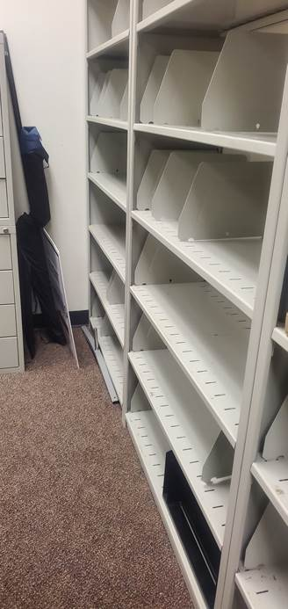
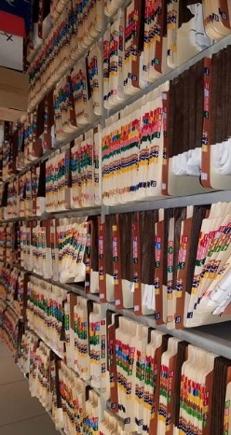
Electronic Records Program
The Town Clerk’s Team has been actively working to convert paper records into digital copies. Over the past year, efforts to digitize paper files have continued, and as of now, there are 348,781 documents, comprising 1,783,328 pages, available to the public in digital format.
Community Outreach

Florida City Government Week
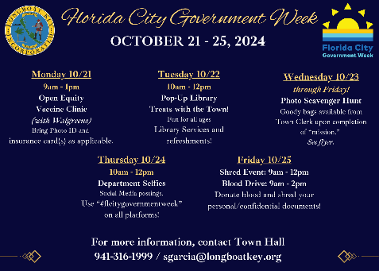
In October 2024, the Town of Longboat Key took part in Florida City Government Week. The Town Clerk’s Team organized and sponsored a series of inclusive and free events for Town residents and businesses to celebrate the occasion, including:
Free Vaccine Clinic. In partnership with Walgreens, Inc., the vaccine clinic offered free flu and COVID-19 vaccines/boosters and had shingles, RSV, pneumonia, and Tdap vaccines available.

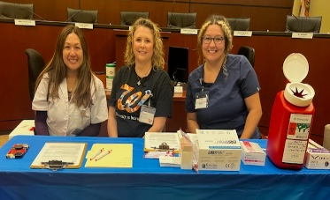

A blood drive (in partnership with SunCoast Blood Centers) was held in conjunction with the document shredding. The Community and Town Staff participated, and it was a successful blood drive. Thank you to all who donated, saving lives!
Department Selfie Day
On-Site Shredding Day! Residents and businesses were able to utilize our “drive-thru” services for secure, on-site, document shredding. Over 40 bins of documents were destroyed!
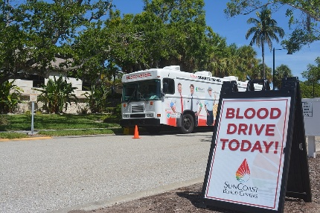



Notary Services
The Town Clerk’s Team offers free Notary Service to Longboat Key residents and property owners. Over the last year, 287 documents were notarized for our residents and property owners.
Public Records Requests
The Town Clerk’s Team processes records requests received from the public. Records may be requested by phone, e-mail, in person, or through our electronic records request system on the Town’s website. During the last year, 624 requests were processed. Of those requests, 84% were completed and returned to the requester within 24 hours or less!
Emergency Management Response
The Town Clerk’s Team plays an essential role in the Emergency Response Efforts during storm events. Throughout the 2024 Hurricane Season, one Clerk Team member was stationed at the Emergency Operations Center (EOC) in Sarasota, while other members supported the response by handling resident and business calls remotely, as Town Hall and most of the Town were closed due to evacuation orders and storm impacts. Together, with assistance from a Finance Team member, the Clerk’s Team successfully fielded over 7,500 calls remotely before, during, and after the hurricanes.
Community Outreach
Longboat Key Clerk Team member, Stephanie Garcia (top left in photo) stationed at the Sarasota County EOC facility during the hurricanes.

U.S. Marine Corps Reserve “Toys for Tots” Campaign - The Clerk’s Team coordinated the annual drive to collect new, unwrapped toys from early November 2024 to December 9, 2024. Employees and residents generously donated toys, helping to make it a successful event for local kids.

